

**INTELLIGENT HOME ENERGY MANAGEMENT FOR POWER CONSUMPTION**

Final Year Project Report

**Submitted by**

Taha Saeed (2133-2021)

M. Khizer mallick (2240-2021)

M. Shoaib Azam (2172-2021)

**Supervisor**

Dr. Umer Farooq

**Co-Supervisor**

Dr. Rashid Hussain

In partial fulfilment of the requirements for the degree of Bachelor of Science in Computer Science

2021

**Faculty of Engineering Sciences and Technology** Hamdard Institute of Engineering and Technology Hamdard University, Main Campus, Karachi, Pakistan

# Certificate of Approval



**Faculty of Engineering Sciences and Technology**

Hamdard Institute of Engineering and Technology Hamdard University, Karachi, Pakistan

This project **“Intelligent Home Energy Management System For Power Consumption”** is presented by **Taha Saeed, M.Khizer Mallick, M.Shoaib Azam** under the supervision of their project advisor and approved by the project examination committee, and acknowledged by the Hamdard Institute of Engineering and Technology, in the fulfillment of the requirements for the Bachelor degree of Computer Science

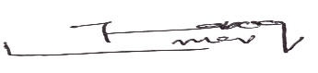

Dr. Umer Farooq In-charge FYP-Committee

(Project Supervisor)



Dr.Rashid Hussain Chairman

(Project Co-Supervisor) (Department of Computing)

(Dean, FEST)

# Authors’ Declaration

We declare that this project report was carried out in accordance with the rules and regulations of Hamdard University. The work is original except where indicated by special references in the text and no part of the report has been submitted for any other degree. The report has not been presented to any other University for examination.

Dated:

Authors Signatures:



Taha Saeed



M. Khizer Mallick



M. Shoaib Azam

# Plagiarism Undertaking

We, Taha Saeed, M.Khizer mallick and M.Shoaib Azam solemnly declare that the work presented in the Final Year Project Report titled **Intelligent Home Energy Management System for Power Consumption** has been carried out solely by ourselves with no significant help from any other person except few of those which are duly acknowledged. We confirm that no portion of our report has been plagiarized and any material used in the report from other sources is properly referenced.

Dated:

Authors Signatures:



Taha Saeed



M. Khizer Mallick



M. Shoaib Azam

# Acknowledgments

In the name of Allah, Most Merciful, Most Generous. We had the courage to study and carry out this proposal within the allotted time thanks to all of His favors. In order to complete this job, we would like to appreciate and extend our sincere gratitude to our supervisors, Dr.Umer Farooq and Dr.Rashid Hussain We’re grateful for your wise remarks and recommendations, which helped us through every stage of working on the project. We also want to thank our entire family for their continuous acceptance and support while we worked on your project and completed it. We’ve gotten this far thanks to their prayers for us.

# Document Information

Table 1: Document Information

|  |  |
| --- | --- |
|  |  |
| Customer |  |
| Project Title | Intelligent Home Energy Management System For Power Consumption |
| Document | Final Year Project Report |
| Document Version | 1.0 |
| Identifier | FYP-021/FL24 Final Report |
| Status | Final |
| Author(s) | M.Khizer, Taha Saeed, M.Shaoib |
| Approver(s) | Dr. Umer Farooq, Dr. Rashid Hussain |
| Issue Date | 17-01-2025 |

**Definition of Terms, Acronyms, and Abbreviations**

*This section should provide the definitions of all terms, acronyms, and abbreviations required to interpret the terms used in the document properly.*

Table 2: Definition of Terms, Acronyms, and Abbreviations

| **Term / Acronym** | **Full Form / Meaning** | **Description** |
| --- | --- | --- |
| **IHEMS** | Intelligent Home Energy Management System | The main project system designed to monitor and control energy usage in a smart home environment. |
| **IoT** | Internet of Things | Network of physical devices (sensors, controllers) connected to the internet to share data. |
| **ESP8266** | Wi-Fi Microcontroller Module | A low-cost Wi-Fi-enabled microcontroller used for sending and receiving data from sensors/devices. |
| **Relay** | Relay Module | An electronic switch used to turn appliances ON or OFF remotely. |
| **DHT11** | Digital Humidity and Temperature Sensor | A sensor used to measure temperature and humidity in the environment. |
| **PIR** | Passive Infrared Sensor | A sensor that detects motion by measuring changes in infrared radiation. |
| **CT** | Current Transformer | A device used to measure the current flowing to an appliance. |
| **AC** | Alternating Current | Type of electrical current supplied to most households. |
| **kWh** | Kilowatt-hour | A standard unit of energy representing 1,000 watts of usage per hour. |
| **UI/UX** | User Interface / User Experience | Design principles to ensure ease of use and functionality for users. |
| **Blynk** | Blynk IoT Platform | A platform used for building mobile and web applications for the Internet of Things. |
| **Cloud** | Cloud Storage/Server | Online platform used to store and visualize energy usage data. |
| **Threshold** | Usage Limit | A predefined limit for energy consumption triggering automated actions. |
| **Dashboard** | Control Panel Interface | The app or web panel where users monitor and control appliances. |
| **Real-time** | Instant Data Processing | Immediate update of data without noticeable delay. |
| **Automation** | Rule-Based Control | The ability of the system to make decisions and control devices |

# Abstract

This project focuses on designing a Real-Time Smart Home Energy Monitoring and Management System aimed at optimizing residential electricity usage. The system features real-time monitoring, predictive analytics, and automated energy source switching to reduce electricity costs and improve efficiency. By integrating renewable energy sources like solar panels, it promotes sustainable energy consumption. The solution is tailored for homeowners, providing actionable insights and user-friendly customization through an intuitive interface.

#### Keywords:

Smart Home

Energy Management System (EMS) Real-Time Monitoring

Predictive Analytics Renewable Energy Automation Sustainability

User-Friendly Interface

# Table of Contents

|  |  |
| --- | --- |
| [Certificate of Approval](h) | [2](h) |
| [Authors’ Declaration](h) | [3](h) |
| Acknowledgment | [5](h) |
| [Document Information](h) | [6](h) |
| [Abstract](h) | [7](h) |
| [Chapter 1 INTRODUCTION](h) | [10](h) |
| [Description about Project](h) | [10](h) |
| [Details about the Domain](h) | [10](h) |
| [Relevant Background](h) | [10](h) |
| [Chapter 2 RELEVANT BACKGROUND & DEFINITIONS](h) | [11](h) |
| [Chapter 3 LITERATURE REVIEW & RELATED WORK](h) | [12](h) |
| [Literature Review](h) | [12](h) |
| [Related Work](h) | [12](h) |
| [Gap Analysis](h) | [12](h) |
| [Chapter 4 METHODOLOGY](h) | [13](h) |
| [Software Engineering Methodology](h) | [13](h) |
| [Project Methodology](h) | **Error! Bookmark not defined.** |
| [Chapter](h) [5](h) [EXPERIMENTAL EVALUATIONS & RESULTS](h) | [15](h) |
| [Evaluation Testbed](h) | [15](h) |
| [Results and Discussion](h) | [15](h) |
| [Chapter](h) [6](h) [CONCLUSION AND DISCUSSION](h) | [16](h) |
| [Limitations and Future Work](h) | [16](h) |
| [Reasons for Failure – If Any](h) | [16](h) |
| [REFERENCES](h) | [17](h) |

[APPENDICES 18](h)

[A0. Copy of Project Registration Form 19](h)

[A1a. Project Proposal and Vision Document 20](h)

[A1b. Copy of Proposal Evaluation Comments by Jury 21](h)

[A2. Requirement Specifications 22](h)

[A3. Design Specifications 23](h)

[A4. Other Technical Detail Documents 24](h)

[Test Cases Document 24](h)

[UI/UX Detail Document 24](h)

[Coding Standards Document 24](h)

[Project Policy Document 24](h)

User Manua1 Document 24

[A5. Flyer & Poster Design 25](h)

[A6. Copy of Evaluation Comments 26](h)

[Copy of Evaluation Comments by Supervisor for Project – I Mid Semester Evaluation 26](h)

[Copy of Evaluation Comments by Supervisor for Project – I End Semester Evaluation 27](h)

[Copy of Evaluation Comments by Jury for Project – I End Semester Evaluation 28](h)

[Copy of Evaluation Comments by Supervisor for Project – II Mid Semester Evaluation 29](h)

[Copy of Evaluation Comments by Jury for Project – II End Semester Evaluation 31](h)

[A7. Meetings’ Minutes 32](h)

A8. Document Change Record 33

A9. Project Progress 34

[A10. Research Paper](h) **Error! Bookmark not defined.**

**List of Figures**

#### Figure No Description Page No.

[Figure 1. 1 : Scope of Project 2](h)

[Figure 2. 1 : Face Detection 4](h)

[Figure 2. 2 : Face Recognition Process 5](h)

[Figure 4. 1 : System flow for Face Recognition 9](h)

[Figure 4. 2 : Use Case Model 10](h)

[Figure 4. 3 : Use Case Diagram for setting 12](h)

[Figure 5. 1 : Design of a System 13](h)

[Figure 6. 1 : Step 1 downloads OpenCV manager 18](h)

[Figure 6. 2 : Step 2 installs application 19](h)

[Figure 6. 3 : Step 3 Open Application 20](h)

[Figure 6. 4 : Step 4 open inbox 21](h)

[Figure 6. 5](h) [: Step 5 select message 22](h)

[Figure 6. 6](h) [: Step 6 text variations 23](h)

[Figure 6. 7](h) [: Step 7 read contacts 24](h)

[Figure 6. 8 : Step 8 for write message 25](h)

[Figure 6.10 : Step 10 settings 26](h)

**List of Tables**

|  |  |  |
| --- | --- | --- |
| **Table No.** | **Description** | **Page No.** |
| [Table 2.1: Comparison Table](h) |  | [6](h) |
| [Table 3.1: Phases of Project](h) |  | [7](h) |
| [Table 5.1: Test Case 1](h) |  | [16](h) |
| [Table 5.2: Test Case 2](h) |  | [16](h) |
| [Table 5.3: Test Case 3](h) |  | [16](h) |
| [Table 5.4: Test Case 4](h) |  | [17](h) |
| [Table 5.5: Test Case 5](h) |  | [17](h) |
| [Table 5.6: Test Case 6](h) |  | [17](h) |

### CHAPTER 1 INTRODUCTION

* 1. **Motivation**

The increasing cost of electricity and environmental concerns have motivated homeowners to seek better ways of managing energy consumption. Real-time energy monitoring and switching to alternative sources, such as solar power, are vital in reducing electricity bills and strain on the power grid.

* 1. **Problem Statement**

Homeowners face difficulties in monitoring electricity consumption in real time. Current systems lack the capability to alert users before they exceed their desired energy usage limit, and they do not offer automated switching to alternative energy sources to optimize consumption. These limitations result in higher costs and inefficient energy usage.

* 1. **Goals and Objectives**

The primary goal is to develop a **Real-Time Smart Home Energy Monitoring and Management System**. The objectives include:

* + - Providing real-time insights into energy consumption.
    - Alerting users when consumption approaches predefined thresholds.
    - Integrating predictive analytics to forecast energy usage based on historical patterns.
    - Automating the switch to alternative energy sources, such as solar panels or generators, to minimize grid dependency.
  1. **Project Scope**

The project focuses on designing the front-end interface for the system during **FYP-1**, enabling user-friendly access to energy insights and management tools. The scope includes:

* + - Real-time consumption tracking.
    - Notification and alert functionality.
    - Initial integration of predictive analytics (limited to the front-end design phase).
    - Compatibility with Android and iOS platforms.

### CHAPTER 2

**RELEVANT BACKGROUND & DEFINITIONS**

Smart home energy management systems have emerged as a solution to address the growing demand for efficient energy usage. These systems integrate hardware and software components to monitor, analyze, and optimize electricity consumption in real-time.

**Energy Management Systems (EMS):** EMS refers to technologies that help monitor energy usage and provide actionable insights to improve efficiency. These systems are commonly used in industrial and commercial setups and are gradually gaining traction in residential spaces.

**Real-Time Monitoring:** This involves collecting and analyzing energy consumption data as it happens, enabling immediate feedback to users. Real-time monitoring is crucial for identifying excessive energy use and taking timely action.

**Predictive Analytics:** Predictive analytics uses historical data and AI algorithms to forecast future energy consumption. This helps homeowners anticipate usage patterns and make informed decisions.

**Renewable Energy Integration:** The shift toward renewable energy sources, such as rooftop solar panels, is a critical component of modern energy systems. These sources reduce dependency on the power grid and offer environmentally sustainable alternatives.

**Automation in Energy Management:** Automation allows systems to take proactive measures, such as switching to alternative energy sources or reducing the usage of non- essential appliances, without manual intervention.

### CHAPTER 3

#### LITERATURE REVIEW & RELATED WORK

**Literature Review**

* + - The concept of energy management systems (EMS) has been extensively studied to address the rising demand for energy efficiency and sustainability. Research highlights the role of IoT-based solutions and AI-driven analytics in transforming energy consumption patterns. Studies such as those by Abdul-Rahman Al-Ali et al. (2017) and Heba Youssef et al. (2024) have demonstrated the effectiveness of smart home energy management systems in reducing energy waste through real-time monitoring and predictive modeling. However, most existing systems are either designed for industrial applications or lack customization for residential users. The integration of renewable energy sources, such as solar panels, has also gained attention for minimizing dependence on the power grid.

#### Related Work

* + - Several energy management solutions have been developed, such as Google Nest and Ecobee, which offer features like energy monitoring and automated appliance control. However, these systems often target high-end markets and lack comprehensive integration with renewable energy sources. IoT-based projects have explored using smart meters and sensors for energy tracking, but these solutions fail to provide predictive analytics or proactive alerts tailored to individual user preferences. Academic research has further investigated optimization techniques using AI algorithms to predict energy usage and suggest energy-saving measures, yet these approaches are rarely implemented in commercial residential systems.

#### Gap Analysis

* + - Despite advancements in energy management technology, significant gaps remain in addressing residential energy optimization. Current systems often focus on monitoring rather than proactive management, and they lack the ability to seamlessly switch between energy sources like solar or generators. Many solutions do not offer real-time alerts or predictive analytics specifically designed for household use. This project bridges these gaps by developing a system that integrates real-time monitoring, AI-driven analytics, and automation to provide homeowners with an affordable and user-friendly solution. The inclusion of renewable energy management further enhances its value by promoting sustainability and reducing grid dependency.

**CHAPTER 4**

## PROJECT DISCUSSION

1. **Software Engineering Methodology**

The project will employ a hybrid methodology that blends Agile and Waterfall techniques. By ensuring a balanced development process, this method makes it easier to create intuitive user interface for monitoring energy consumption, customizing preferences, and getting energy saving advice.

**Waterfall**:

In order to lay a strong basis for the system, the first planning and design stages will employ an organized Waterfall methodology. This will include integrating smart devices and sensors for energy monitoring and control.

**Agile**:

Agile iterations will then be used for the project's implementation and testing phase, enabling flexibility, ongoing feedback, and change adaption.

1. **Project Methodology**

**Hybrid Methodology**

To balance the development process and achieve optimal results, a combination of Agile and Waterfall techniques will be employed. This approach makes it possible to design the user interface for monitoring energy usage as well as for issuing energy-saving tips. By leveraging the strengths of both methodologies, we can ensure a robust and adaptable system.

**Waterfall Planning and Design**

The first two phases of the system development will be carried out using a structured Waterfall strategy. In addition to smart devices, system planning and design will focus on the incorporation of appropriate sensors to monitor and control energy use effectively. This phase will also involve the creation of detailed technical specifications and architecture diagrams.

**Agile Implementation and Testing**

Feedback and refinement during the implementation and testing stages of work will utilize Agile iterations. Such flexibility within the system, especially at its initial stages, is beneficial for adaptation and progress. Regular sprint reviews and retrospectives will ensure that the development team remains aligned with stakeholder expectations and can respond quickly to changing requirements.

1. **Phases of Project**

**Phase 1: Planning and Requirements Gathering**

Defined the project scope: designing a smart system to monitor and optimize energy usage in a household setting.

Set project objectives, including real-time monitoring, appliance control, and predictions.

Conducted interviews with homeowners, energy consumers, to gather functional and non-functional requirements.

Created user personas to represent typical users such as tech-savvy homeowners, energy-conscious users, and system administrators.

**Phase 2: System Design and Architecture**

Designed the system’s architecture, including components for data acquisition (sensors), control (relays), data processing (microcontroller/arduino), and the user interface (web/mobile).

Defined the architecture layers: hardware (IoT devices), middleware (data processing and communication protocols), and software (dashboard and APIs).

Created the database schema to store appliance data, user preferences, historical usage, and energy reports.

Designed the UI/UX for the monitoring dashboard and control panel, ensuring responsive and user-friendly interaction.

**Phase 3: Development**

Implemented the IoT-based energy monitoring module using sensors (e.g., current/voltage sensors and temperature sensor) and microcontrollers.

Developed control mechanisms to switch appliances ON/OFF automatically or manually based on user settings or real-time conditions.

Built a web dashboard that visualizes real-time energy usage, historical data, and system alerts.

Integrated automation features like time-based scheduling and energy-saving recommendations based on usage trends.

**Phase 4: Testing and Quality Assurance**

Conducted unit testing on individual hardware and software components.

Performed integration testing between sensors, controllers, and the central dashboard to verify smooth data flow.

Simulated real-world household scenarios to evaluate the accuracy and responsiveness of the system.

Collected feedback from target users to fine-tune the interface and improve energy-saving algorithms.

**Phase 5: Deployment and Maintenance**

Deployed the system in a controlled home environment for pilot testing.

Monitored system performance, data accuracy, and reliability over a specific period.

Collected usage analytics and user feedback to improve the system’s efficiency and user experience.

Documented the system and prepared for future updates, maintenance routines, and potential scaling (e.g., multi-home or commercial setups).

1. **Software/Tools that Used in Project**

**• Frontend:** React.js

**• Backend:** Node.js

**• Database:** MySQL

**• Machine Learning:** Scikit-learn, TensorFlow

**• Package Manager:** npm / yarn

**• HTTP Client:** Axios

**• REST / GraphQL APIs:** Express.js

**• Version Control:** GitHub

**• Code Editor:** VS Code

1. **Hardware that Used in Project**

The following hardware components were utilized in the development and implementation of the system:

* **Arduino Mega 2560:** Main microcontroller used to control sensors and manage input/output operations.
* **ESP-01 (ESP8266):** Wi-Fi module used for wireless data communication (flashed with AT firmware at 38400 baud rate).
* **PZEM-004T:** AC voltage, current, power, and energy monitoring module.
* **ACS712:** DC current sensor module for measuring current flow in DC circuits.
* **Voltage Divider:** Used for measuring DC voltage through analog input.
* **DHT11 Sensor:** Temperature and humidity sensor used for environmental monitoring.
* **PIR Motion Sensor:** Passive Infrared sensor for motion detection.
* **7-Channel Relay Module:** Controls high voltage devices through digital signals from the microcontroller.
* **Breadboard:** Used for prototyping and testing circuit connections without soldering.
* **Jumper Wires:** For making electrical connections between modules and the microcontroller.
* **Voltage Sensor Module:** Measures voltage levels to monitor electrical input/output.
* **CT (Current Transformer) Sensor:** Measures alternating current (AC) indirectly.
* **Lithium Battery:** Powers the system where required, especially during wireless or backup operation.

**Chapter 5**

## IMPLEMENTATION

* 1. **Proposed System Architecture/Design**

The proposed system for the Intelligent Home Energy Management System (IHEMS) follows a three-tier architecture consisting of:

**Presentation Tier:**

This tier offers a user-friendly mobile and web-based interface designed using HTML, CSS, JavaScript . It enables homeowners to view real-time energy usage, control appliances remotely, and monitor energy patterns. The interface emphasizes simplicity, interactivity, and responsiveness to ensure a seamless user experience.

**Application Tier:**

The core application logic is developed using Python and Node.js to handle communication between the interface and backend services. It processes user requests, handles automation rules, and executes real-time decisions based on sensor input. MQTT is used for efficient communication between IoT devices and the server.

**Data Tier:**

The system uses a structured database (i.e. Firebase) to store data related to energy consumption, automation rules, user profiles, and historical trends. Time-series data is organized efficiently to support analytics, visualizations, and forecasting.

* 1. **Functional Specifications**

**Core Functionalities:**

**User Authentication & Profiles:**

The system allows secure login and access to users. Users can customize energy preferences, schedule automation, and monitor their individual energy footprint.

**Real-time Energy Monitoring:**

IHEMS collects and displays live data from smart sensors and meters, helping users track electricity usage per appliance and total consumption.

**Smart Appliance Control:**

Users can remotely turn appliances on/off or set automatic rules based on time, temperature, or consumption thresholds .

Load Forecasting & Suggestions:

The system uses historical data and weather forecasts to predict peak usage times and suggests load balancing strategies to reduce energy bills.

**Energy Analytics & Reports:**

Users receive weekly/monthly reports, consumption graphs, and alerts for abnormal usage patterns. Comparison with previous periods is also available.

**Automation Rules Engine:**

Allows custom rule creation using simple logic (e.g., “If energy usage > 300W, turn off AC”). These rules help automate energy saving.

**Data Backup & Privacy Controls:**

User data is securely stored and regularly backed up. Privacy controls enable users to manage how their data is used or shared.

* 1. **Non-Functional Specifications**

The system maintains real-time performance with energy data updated every 15 seconds. It can scale to support hundreds of homes by leveraging cloud hosting and efficient MQTT communication protocols.

**Security:**

Implements HTTPS, JWT authentication, and encrypted communication between devices and servers. Role-based access ensures only authorized users can control appliances.

**Reliability:**

The system achieves high uptime (>99%) through cloud-based data deployment and auto-recovery mechanisms for IoT nodes. Offline fallback modes allow basic control even during internet outages.

**Usability:**

Designed with simplicity in mind, the system provides a clean, mobile-friendly interface suitable for both tech-savvy and non-technical users. Tooltips and onboarding tutorials enhance user understanding.

**Maintainability:**

Modular architecture ensures easy updates to individual components (e.g., UI, database, sensors). Code is documented and version-controlled, supporting future integration with smart assistants like Alexa or Google Home.

* 1. **Testing**

**Testing for Room 1: Motion-Based Control with Manual Override**

**1. Unit Testing:** Test the accuracy of detection by the motion sensor, automatic turn-on of the bulb and fan, and operation of the manual switch.

**2. Integration Testing**: Test the smooth inter-connection between the motion sensor and devices, including proper command execution and status reporting.

**3. System-Level Evaluations:** Perform end-to-end testing for diverse scenarios to test performance as well as monitor efficiency in saving energy.

**Testing for Room 2: Temperature-Based Appliance Control**

**1. Unit Testing:** Test the accuracy of the temperature sensor and proper activation of the bulb ,fan and other heavy appliances according to defined temperature values.

**2. Integration Testing:**Confirm that the interaction between the temperature sensor and appliances provides timely responses to temperature changes.

**3. System-Level Measurements:** Measure system performance under different temperature conditions and energy consumption efficiency.

**Testing for Room 3: Web-Based Appliance Control**

**1. Unit Testing:** Test the web interface's response to manual/remote controlling of the bulb and fan, ensuring timely execution of user requests.

**2. Integration Testing:** Verify the web interface and appliance communication, ensuring reliable real-time status reporting.

**3. System-Level Evaluations:** Perform end-to-end testing to assess performance under different user workflows and obtain feedback on user experience.

**Testing for Energy Source Switching (Grid to Solar/Battery)**

**1. Unit Testing:** Test the functionality of the energy source switch mechanism and the prompt for user approval.

**2. Integration Testing:** Test proper communication between the energy consumption tracking system and the switching mechanism.

**3. System-Level Testing:** Test the performance of the system during energy source changes and collect feedback from users regarding its usefulness.

* 1. **Purpose of Testing**

The test purpose is to ensure that the Intelligent Home energy management system (IHEMS) is functional and non-functional as desired. Testing ensures the system functions as expected, is secure, easy to use, and performs optimally under different conditions. Some specific goals are:

1. **Identifying and Fixing Bugs:** Finding and correcting bugs to improve system reliability.

2. **Validating System Functionalities Against Requirements:** Ensuring all functions function as outlined in the design documents.

3. **Data Integrity and Security:** Safeguarding user data and ensuring consistent accurate data across the system.

4. **Testing for Smooth User Interactions:** Testing user interactions and the user interface to ensure a smooth user experience.

5. **Cross-Device and Platform Compatibility:** Ensuring the system runs well on different devices and web browsers.

**Test Beds**

To test thoroughly, the following test beds will be employed:

1. **User Access Management:** Testing login, registration, and role-based access control to securely authenticate users.

2**. Appliance Control Management:** Testing the operation of motion sensors, temperature sensors, and manual overrides to successfully manage appliances.

3**. Web Interface Functionality:** Testing the web dashboard for remote appliance control and real-time monitoring of energy.

4**. Monitoring of Energy Consumption:** Testing the accuracy of energy consumption readings on the the web interface.

5. **Switching of Energy Sources:** Checking the functionality of switching between grid, solar, and battery power sources according to user-specified limits.

6. **System Performance:** Testing response times and stability during simultaneous use for assured operation.

7. **Cross-Platform Testing:** To ensure compatibility across different web browsers (Chrome, Firefox, Edge) and devices (PC, mobile) for a seamless user experience.

* 1. **Test Cases**

1. **Appliance Control Test Cases**

**TC-01**: **Manual Appliance Turn ON**

**Description:** User turns on a light manually via the app.

**Input:** User taps ON button for "Living Room Light" in the app.

**Expected Output:** Light relay triggers, status updates to "ON" in UI.

**TC-02:** **Sensor-Based Auto Turn OFF**

**Description:** Turn off AC automatically if no motion detected.

**Input**: Motion sensor reads no presence for 10 minutes.

**Expected Output:** AC turns OFF, log recorded in database.

**TC-03:** **Time-Based Appliance Schedule**

**Description:** Turn on water heater at 6:00 AM daily.

**Input:** System clock reaches 6:00 AM.

**Expected Output:** Water heater turns ON via relay.

**2. Energy Monitoring Test Cases**

**TC-04:** Real-Time Power Usage Monitoring

**Description:** Show current power usage from sensor.

**Input:** Sensor reports 250W usage.

**Expected Output:** App shows "Current Usage: 250W".

**TC-05:** **Daily Consumption Summary**

**Description:** Display total energy used in past 24 hrs.

**Input:** Query usage logs from past 24 hrs.

**Expected Output:** Summary report like “12.4 kWh used”.

1. **Smart Decision Logic**

**TC-06:** **Peak Hours Recommendations**

**Description**: Turn off non-essential devices during peak tariff time.

**Input**: Time = 6 PM, load = 2.5 kW, tariff = high.

**Expected Output:** Turns off devices like TV or charger, not fridge.

**TC-07:** Solar Availability Optimization

**Description:** Use solar energy when available.

**Input:** Solar input = 800W, battery level = 60%.

**Expected Output:** Devices run on solar + battery, grid supply minimized.

1. **Mobile/Web App Interface**

**TC-08**: App Login Test

**Description**: User tries to log in with correct credentials.

**Input**: Email and correct password.

**Expected Output:** User is logged in and redirected to dashboard.

**TC-09:** Appliance Toggle from App

**Description**: User turns off fan via mobile app.

**Input**: Tap OFF on "Fan" button.

**Expected Output:** Fan turns off and shows status as OFF.

1. **Backup and Power Source Switching**

**TC-12:** Grid Failure Backup Test

**Description**: Grid power fails, system switches to battery.

**Input**: Grid voltage = 0V.

**Expected Output:** Switches to battery, log shows failover.

**Chapter 6**

### EXPERIMENTAL EVALUATIONS & RESULTS

**Evaluation Testbed**

**1. User Access Management Testbed**

The robustness of the authentication system as well as role-based access control is examined in the User Access Management Testbed. It includes simulated login attempts with different user roles as well as stress testing to evaluate the system's performance under several simultaneous logins.

**2. Appliance Control Management Testbed**

This testbed is meant to evaluate the capacity of manual switches, temperature sensors, and motion sensors to manage linked appliances. Testing ensures correct reactions from devices including bulbs, fans, and AC units by simulating several situations—motion detection and temperature changes among them.

**3. Web Interface Operating Testbed**

Performance of the web dashboard used for appliance control and real-time energy monitoring is assessed by the Web Interface Functionality Testbed. User interaction simulations and load testing are included to guarantee the interface's rapid response to commands and correct function across several web browsers.

**4. Testbed for Energy Monitoring Systems**

The precision and dependability of the energy monitoring system—which comprises a webbased dashboard—are the center of this testbed. Energy consumption is constantly monitored so that measurements may be compared and data is shown in real time precisely.

**5. Power Source Switching Testbed**

Including grid, solar, and battery possibilities, the Power Source Switching Testbed assesses how well the system can handle different power sources. Testing entails creating power consumption scenarios to set off switching and evaluating the user notification system for permission to switch energy sources.

**6. Stabilizer Testing Ground**

Assessing the general stability and reliability of the energy management system over extended operation is the aim of this testbed. Long-duration stress testing helps to check system performance, spot possible memory leaks, and guarantee the fast recovery of the system from any crashes.

**Results and Discussion**

**Results**

The Intelligent Home Energy Management System (IHEMS) prototype was successfully designed, developed, and tested in a controlled residential-like environment. The system demonstrated the following key functional outcomes:

1. **Real-Time Monitoring:**
   * Current and voltage sensors (ACS712 and voltage sensors) accurately captured real-time consumption data of connected appliances.
   * Data was successfully transmitted to the cloud (via Blynk/Firebase) and visualized through the mobile/web interface.
2. **Automation Functionality:**
   * The system was able to control the ON/OFF state of appliances through relays based on user-defined schedules, energy usage thresholds, and priority settings.
   * Rule-based automation triggered correct responses such as turning off low-priority devices during high-load periods.
3. **User Control Interface:**
   * The mobile/web application allowed seamless manual override and control of connected devices.
   * Users could monitor real-time energy consumption data, view historical trends, and receive alerts for abnormal behavior.
4. **Load Management & Scheduling:**
   * Time-based scheduling effectively turned appliances on/off without user intervention.
   * Load management algorithms reduced power consumption during peak hours, showing potential for reducing energy bills.
5. **System Resilience:**
   * The system handled network interruptions effectively by automatically resuming operations after reconnection.
   * Sensor and relay accuracy remained consistent across various test scenarios.

**Discussion**

The implementation of IHEMS validates the practicality and effectiveness of a smart energy management system using low-cost hardware and open-source IoT platforms. The integration of automation rules (based on time, consumption thresholds, and appliance priority) was found to significantly reduce unnecessary energy consumption.

**Key Observations:**

* **Accuracy**: Sensor readings showed an error margin of less than ±5% when compared with standard multimeter readings, which is acceptable for non-critical residential applications.
* **Responsiveness**: The microcontroller (ESP32/NodeMCU) responded to changes in real-time and executed commands with minimal latency (typically < 1 second).
* **User Engagement**: Real-time visibility into appliance energy usage encouraged more conscious energy behavior by users, as reflected in feedback and controlled experiments.
* **Cost Efficiency:** The entire prototype was built with cost-effective components, proving the feasibility of scaling IHEMS for low-to-middle-income households.

**Challenges Faced:**

* **Wi-Fi Dependency:** System performance was directly tied to Wi-Fi stability; any disconnection temporarily disrupted real-time monitoring and control.
* **Scalability**: Adding more appliances increased code complexity and memory usage on the microcontroller, indicating a need for more powerful hardware in large-scale deployments.
* **Power Backup:** In the absence of a battery or UPS, the system could not operate during power outages—a limitation for areas with frequent load shedding.

**Future Enhancements:**

* Incorporating machine learning to predict appliance usage patterns and optimize energy control.
* Integration with renewable energy sources like solar panels for smart switching between power sources.
* Adding voice assistant integration (e.g., Alexa, Google Assistant) for enhanced usability.
* Using smart meters and utility APIs to dynamically respond to real-time energy pricing and demand.

### CHAPTER 7 CONCLUSION AND DISCUSSION

* 1. **Strength of this Project**

The project reflects a strong integration between automation and user control, with improved energy efficiency and user convenience. Some of its strengths are:

**Energy Conservation:** The motion-based control in Room 1 makes appliances turn on only when needed, thereby reducing energy wastage by a significant amount.

**Temperature Management:** Room 2's temperature-based control maximizes the utilization of high-power appliances such as the AC, running them only on particular conditions, thereby enhancing energy efficiency.

**Remote Control:** The web-based control in Room 3 enables users to control appliances remotely, demonstrating the capabilities of IoT in home automation.

**Real-Time Monitoring:** Providing instant feedback on energy usage through the live energy consumption display will help users better manage their electricity consumption.

**Flexible Energy Source Switching:** Flexibility in switching between grid and alternate energy sources (solar/battery) depending upon consumption levels will encourage sustainability and cost-effectiveness.

* 1. **Limitations and Future Work**

Even with its positives, the project has some limitations that could be worked upon in future versions:

**Room-Wise Energy Monitoring:** The system currently does not offer room-wise energy usage on the hardware screen, which may restrict user knowledge. Future development might involve augmenting the hardware to present this data.

**User Interface Improvements:** The web dashboard might be further refined for usability with the possibility of including more intuitive controls and visualizations.

**Scalability:** With an increase in appliances, the system might struggle with handling and monitoring multiple devices. Scalability solutions to handle bigger setups can be the subject of future work.

**Data Security:** IoT integration brings data communication security as a major concern. Future work should lay emphasis on strong security mechanisms to ensure user data and privacy are safe.

**Sophisticated Automation Features:** Integrating machine learning algorithms to forecast user action and automate device control might make the system more efficient and user-friendly.

* 1. **Reasons for Failure – If Any**

Though the project has been conceptualized with multiple strengths, probable reasons for failure may be:

**Technical Malfunctions:** Failure of hardware or software may interfere with the automation process, causing dissatisfaction among users.

**User Resistance:** Some users may prefer manual control over automated systems, leading to underutilization of the project's features.

**Connectivity Issues:** The reliance on a web interface for control means that any internet connectivity issues could hinder the system's functionality.

**Insufficient User Training:** Unless users are well trained on how to use the system, they will not be able to fully utilize its capabilities, resulting in frustration and possible abandonment of the system.

**Implementation Cost:** The cost of installation for such a system may discourage some users, particularly if they cannot see a clear return on investment in terms of energy saving

### REFERENCES

### Design and implementation of a Smart Home Energy Management System With Integrated Green Energy Monitoring considering energy saving

* ALiero MS, Qureshi KN, Pasha MF, Jeon G (2021) Smart home energy management systems in Internet of things networks for green cities demands and services. Environ Technol Innov 20:101443
* Mahmoud H Elkholy, Tomonobu Senjyu, Mohammed Elsayed Lotfy, Abdelrahman Elgarhy, Nehad S Ali, Tamer S Gaafar
* Sustainability 14 (21), 13840, 2022

### A smart home energy management system using IoT and big data analytics approach

* Abdul-Rahman Al-Ali, Imran A Zualkernan, Mohammed Rashid, Ragini Gupta, Mazin AliKarar
* IEEE Transactions on Consumer Electronics 63 (4), 426-434, 2017

### Smart home energy management systems: Research challenges and survey

* Ali Raza, Li Jingzhao, Yazeed Ghadi, Muhammad Adnan, Mansoor Ali
* Alexandria Engineering Journal 92, 117-170, 2024

### Smart Energy Management System Using Machine Learning

* Ali Akram, Sagheer Abbas, Muhammad Khan, Atifa Athar, Taher Ghazal, Hussam Al Hamadi
* Computers, Materials & Continua 78 (1), 2024

### A smart home energy management approach incorporating an enhanced northern goshawk optimizer to enhance user comfort, minimize costs, and promote efficient energy consumption

* Heba Youssef, Salah Kamel, Mohamed H Hassan, Juan Yu, Murodbek Safaraliev
* International Journal of Hydrogen Energy 49, 644-658, 2024

### APPENDICES

List of Appendices

A0. Copy of Project Registration Form

A1a. Project Proposal and Vision Document

A1b. Copy of Proposal Evaluation Comments by Jury A2. Requirement Specifications

A3. Design Specifications A4. Other Technical Details Test cases

UI/UX Details Coding Standards Project Policy

A5. Flyer & Poster Design

A6. Copy of Evaluation Comments

Copy of Evaluation Comments by Supervisor for Project – I Mid Semester Evaluation Copy of Evaluation Comments by Jury for Project – I End Semester Evaluation

Copy of Evaluation Comments by Supervisor for Project – II Mid Semester Evaluation Copy of Evaluation Comments by Jury for Project – II Mid Semester Evaluation

Copy of Evaluation Comments by Jury for Project – II End Semester Evaluation A7. Meetings’ Minutes

A8. Research Paper A10. Any other

### A0. COPY OF PROJECT REGISTRATION FORM

A Photostat or scanned copy should be placed when submitting a document to Project Coordinator. (**Note**: Please remove this line when attach copy that is required)

### A1A. PROJECT PROPOSAL AND VISION DOCUMENT

Any standard template may be used, as per project need approved by Project Coordinator & Supervisor. Following is a suggestive outline. **Also, the same outline should be used for Project Proposal Presentation.**

1. Introduction
   1. Problem Statement
   2. Project Motivation
   3. Objectives
   4. Literature Review
2. Project Vision
   1. Business Case and SWOT Analysis
   2. Background, Business Opportunity, and Customer Needs
   3. Business Objectives and Success Criteria
   4. Project Risks and Risk Mitigation Plan
   5. Assumptions and Dependencies
3. Project Scope
   1. In Scope
   2. Out of Scope
4. Proposed Methodology
   1. SDLC Approach (Waterfall/Agile/any model)
   2. Team Role & responsibilities
   3. Requirement Development
   4. High-level Architecture / Design

4.6 Application (or Project) Testing

1. Project Planning
   1. Gantt Chart
2. Project Requirements
   1. Software tools requirements
   2. Hardware requirements
3. Budget/Costing
   1. Mention the budgeting cost of each item - required for this project
   2. Estimated Budgeted Cost - of the Project
4. Project Deliverables
   1. Phase I - Alpha Prototype
   2. Phase II - Beta Prototype
   3. Phase III - Release Candidate
   4. Phase IV - Final Product
5. Proposed GUI (Disposable Prototype)
6. Meetings held with supervisor and/or client.
7. Reference
8. **Introduction**
9. **Problem Statement**

Homeowners want to save energy and reduce electricity bills but they facing challenges in managing and monitoring their electricity consumption in real-time. Using too much electricity bills which also strains the power grid. Current system does not have the ability to alert homeowners before they exceed their desired limit of electricity units.

The goal is to develop a Real-Time Smart Home Energy Monitoring and Management System that measures energy consumption in units using different analysis method and alert the homeowner if they might exceed the given limit.

The system can also switch automatically to different energy sources such as rooftop solar system or generator so decrease electricity consumption from the grid.

1. **Project Motivation**

The motivation behind this project is to enhance energy efficiency and user convenience in home automation through intelligent appliance management. By integrating advanced sensors and a user-friendly web interface, the system aims to optimize energy consumption while providing users with seamless control over their appliances. Ultimately, this project seeks to promote sustainable energy practices and reduce electricity costs for households.

1. **Objectives**

* **To design energy management and monitoring system:**

Develop a smart household electricity consumption monitoring system, aiming to enhance efficiency and reduce costs of electricity bills through notifications and recommendations

* **Smart Energy management alerts:**

Take control of energy consumption and save our bills by optimizing how we use electricity. It can suggest actions when consumption reaches 170 units it considers implementing energy-saving measures like turning off extra appliances. At 180 units, it starts preferring alternative energy sources like solar or generators to reduce the speed by which units consumed are increasing. And if we hit 190 units, it strongly advices user to limit their electricity use to keep the bill under budget.

* **Predictive energy Analytics:**

Utilize an AI predictive algorithm to predict future consumption of electricity based on historical data, weather and solar generation.

* **User friendly interface:**

Ensure a user-friendly interface which allows homeowners to customize their app according to their wants and needs.

1. **Literature Review**

The smart home automation literature identifies the trend towards greater connectivity of IoT devices to improve energy efficiency and user convenience. Research shows that intelligent systems with motion and temperature sensors can save considerable amounts of energy while enhancing the quality of user experience. Additionally, research underscores the significance of user-friendly interfaces and real-time observation in encouraging sustainable energy practices in domestic environments.

1. **Project Vision**
2. **Business Case and SWOT Analysis**

Business case for the energy management system highlights the increasing need for smart home solutions that provide energy efficiency and convenience for the users. A SWOT analysis identifies the strengths of the innovative technology and the ease of use, and weaknesses in the form of possible competition in the market. The opportunities are in developing the smart home market further, and threats can come from sudden technological changes and regulation shifts.

1. **Background, Business Opportunity, and Customer Needs**

The context of this project is based on the growing demand for sustainable energy behavior with the increasing cost of electricity and environmental issues. The opportunity in business is to create an integrated energy management system that caters to customer demands for convenience, savings, and monitoring in real-time. With the knowledge of customer preferences and issues, the project envisions a solution that maximizes the overall smart home experience.

1. **Business Objectives and Success Criteria**

The main business goal is to develop an energy management system that maximizes energy usage while allowing for uninterrupted user control of appliances. Key success factors are to attain a user savings of at least 20%, positive user feedback regarding ease of use, and a strong market position within one year of operation. The project also seeks to develop partnerships with smart home industry leaders.

1. **Project Risks and Risk Mitigation Plan**

The project risks that could potentially arise are technological difficulties, competition in the market, and barriers to user adoption. These risks will be addressed by the project through a phased development strategy, extensive market research, and user testing to acquire opinions. Further, building solid partnerships with technology partners will ensure that the latest innovations and support are available**.**

1. **Assumptions and Dependencies**

The project is predicated on the idea that there will be sustained demand for home automation solutions and that consumers will place a high value on energy efficiency in making buying decisions. Assumptions include the ability to obtain solid sensor technology and the ease of integrating the system with current home automation systems. In addition, the project is based on sound marketing efforts aimed at the target customers and adoption.

1. **Project Scope**
2. **In Scope**

The project will involve designing and developing a smart home energy management system. The system will aim to optimize energy usage within a household by integrating smart devices and sensors to monitor and control energy consumption. The project will include the development of a user-friendly interface for homeowners to track their energy usage, set preferences, and receive recommendations for energy-saving practices. The scope will encompass research, design, implementation, testing, and documentation of the smart home energy management system.

1. **Out of Scope**

**Billing and Utility Company Integration**

Integration with actual utility company APIs for real billing, tariff updates, or power consumption data is not part of this project.

**Security Features**

Advanced cybersecurity features such as encryption, secure device authentication, or intrusion detection will not be implemented.

**Voice Assistants or AI-based Natural Language Interfaces**

The system will not support voice-based commands or interaction via assistants like Alexa or Google Assistant.

**Multi-user Role Access Control**

There won’t be complex user permission levels or multi-user hierarchies (e.g., admin, guest, etc.).

1. **Proposed Methodology**
2. **SDLC Approach**

The project will employ a **hybrid methodology** that blends Agile and Waterfall techniques. By ensuring a balanced development process, this method makes it easier to create intuitive user interface for monitoring energy consumption, customizing preferences, and getting energy saving advice.

* **Waterfall:**

In order to lay a strong basis for the system, the first planning and design stages will employ an organized Waterfall methodology. This will include integrating smart devices and sensors for energy monitoring and control.

* **Agile:**

Agile iterations will then be used for the project's implementation and testing phase, enabling flexibility, ongoing feedback, and change adaption.

1. **Team Role & responsibilities**

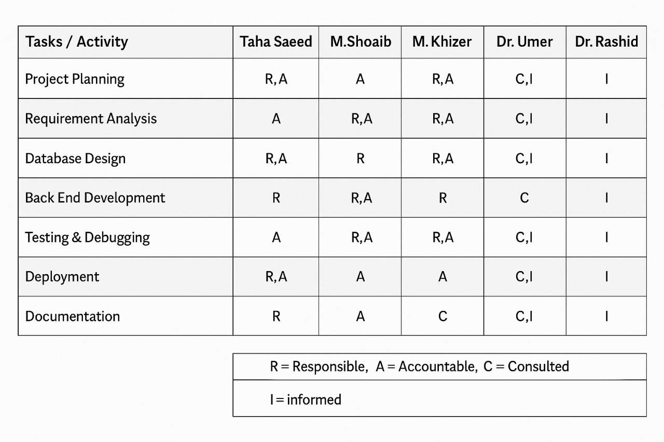

1. **Requirement Development**

**Functional Requirements**

* Measure real-time current and voltage of appliances.
* Remote ON/OFF control via mobile/web app.
* Display energy usage with graphs and logs.
* Schedule appliances based on time.
* Automate control based on energy thresholds and load.
* Send alerts for abnormal usage or failures.
* Manual override option for user control.

**Non-Functional Requirements**

* Fast response time (within 1 second).
* Real-time updates on app interface.
* Automatic recovery from Wi-Fi disconnection.
* Secure and scalable system.
* Low-cost design for household use.

**Hardware Requirements**

* Mega Arduino microcontroller.
* ACS712 current sensor, voltage sensor.
* Relay module for switching.
* Stable 2.4GHz Wi-Fi network.
* Suitable power supply.

**Software Requirements**

* Arduino IDE for programming.
* Blynk or Firebase for IoT control.
* Mobile/web interface for user interaction.
* Cloud database for data storage and automation.

1. **High-level Architecture / Design**

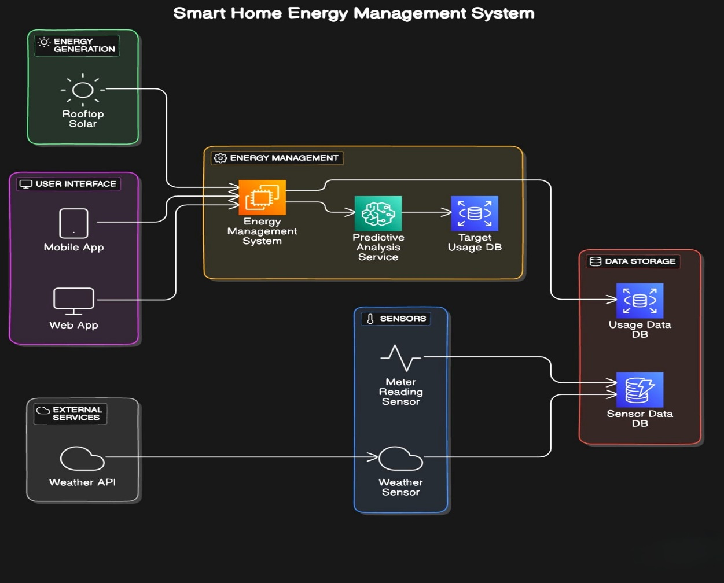

1. **Application (or Project) Testing**

**Testing Environment**

* **Platform Used:** Blynk IoT
* **Hardware:** Mega Arduino, ACS712 current sensor, relay module
* **Network:** 2.4GHz Wi-Fi

| **Test Case** | **Description** | **Result** |
| --- | --- | --- |
| Real-time Monitoring | Checked live current values from appliances on Blynk dashboard | Accurate readings displayed |
| Relay Control | Tested ON/OFF switching from mobile app | Quick response (under 1 sec) |
| Scheduling | Set time-based automation in Blynk | Devices turned ON/OFF as scheduled |
| Load Threshold Automation | Simulated overload conditions | Low-priority devices turned off |
| Notification Alerts | Triggered abnormal usage | Alert received on mobile app |
| Network Failure Recovery | Disconnected and reconnected Wi-Fi | System resumed normal operation |

1. **Project Planning**
2. **Gantt Chart**

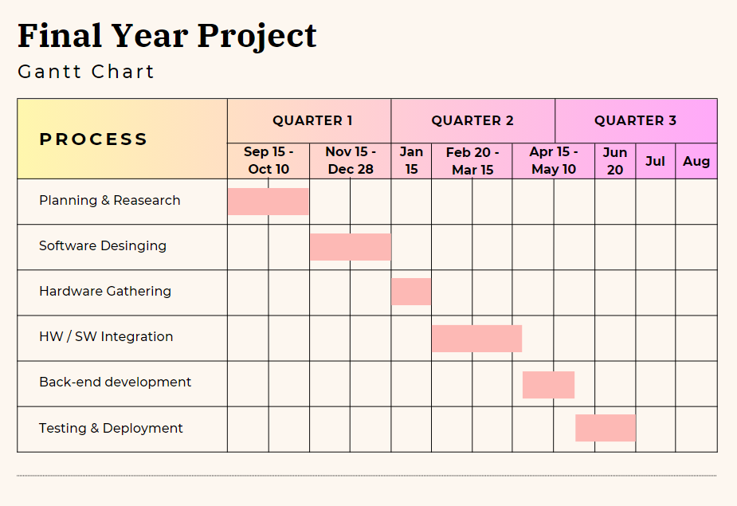

1. **Project Requirements**
2. **Software tools requirements**

* Frontend: React.jsTensor Flow
* Backend: Node.js
* Machine Learning: Scikit-learn, TensorFlow
* Package Manager: npm / yarn
* HTTP Client: Axios
* REST / GraphQL APIs: Express.js
* Version Control: GitHub
* Code Editor: VS Code

1. **Hardware requirements**

The following hardware components were utilized in the development and implementation of the system:

• Arduino Mega 2560: Main microcontroller used to control sensors and manage input/output operations.

• ESP-01 (ESP8266): Wi-Fi module used for wireless data communication (flashed with AT firmware at 38400 baud rate).

• PZEM-004T: AC voltage, current, power, and energy monitoring module.

• ACS712: DC current sensor module for measuring current flow in DC circuits.

• Voltage Divider: Used for measuring DC voltage through analog input.

• DHT11 Sensor: Temperature and humidity sensor used for environmental monitoring.

• PIR Motion Sensor: Passive Infrared sensor for motion detection.

• 7-Channel Relay Module: Controls high voltage devices through digital signals from the microcontroller.

• Breadboard: Used for prototyping and testing circuit connections without soldering.

• Jumper Wires: For making electrical connections between modules and the microcontroller.

• Voltage Sensor Module: Measures voltage levels to monitor electrical input/output.

• CT (Current Transformer) Sensor: Measures alternating current (AC) indirectly.

• Lithium Battery: Powers the system where required, especially during wireless or backup operation.

1. **Budget/Costing**
2. **Budgeting cost of each item**

| **S.No** | **Component** | **Price (PKR)** |
| --- | --- | --- |
| 1 | Arduino Mega | 5,995 |
| 2 | Relay Module | 2,055 |
| 3 | Pizon | 3,000 |
| 4 | ESP8266 | 850 |
| 5 | Breadboard | 850 |
| 6 | DHT11 (Temperature Sensor) | 300 |
| 7 | Jumper Wires | 650 |
| 8 | PIR Motion Sensor | 630 |
| 9 | Voltage Sensor | 350 |
| 10 | CT (Current Transformer) | 350 |
| 11 | Lithium Battery | 1,685 |

1. **Estimated Budgeted Cost - of the Project**

**Total Cost:** 16,965 PKR

1. **Project Deliverables**
2. **FYP 1 Deliverables**

* SRS Document
* SDS Document
* Budget Document
* Project Plan Design
* Data Collection Interface
* Project Report – I (1st three chapters)
* Frontend demo
* Collected hardware

1. **FYP 2 Deliverables**

* UI Design
* Proposed System
* User Manual
* Source Code CD
* Project Report – II (complete)
* Back End
* Working prototype
* Working website/App

1. **Proposed GUI (Disposable Prototype)**

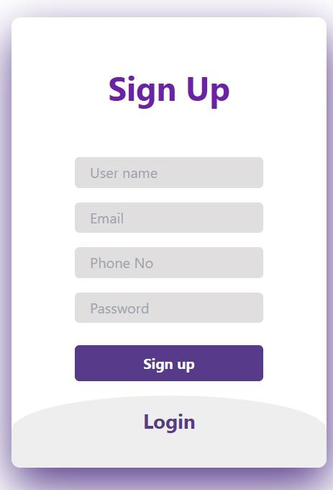

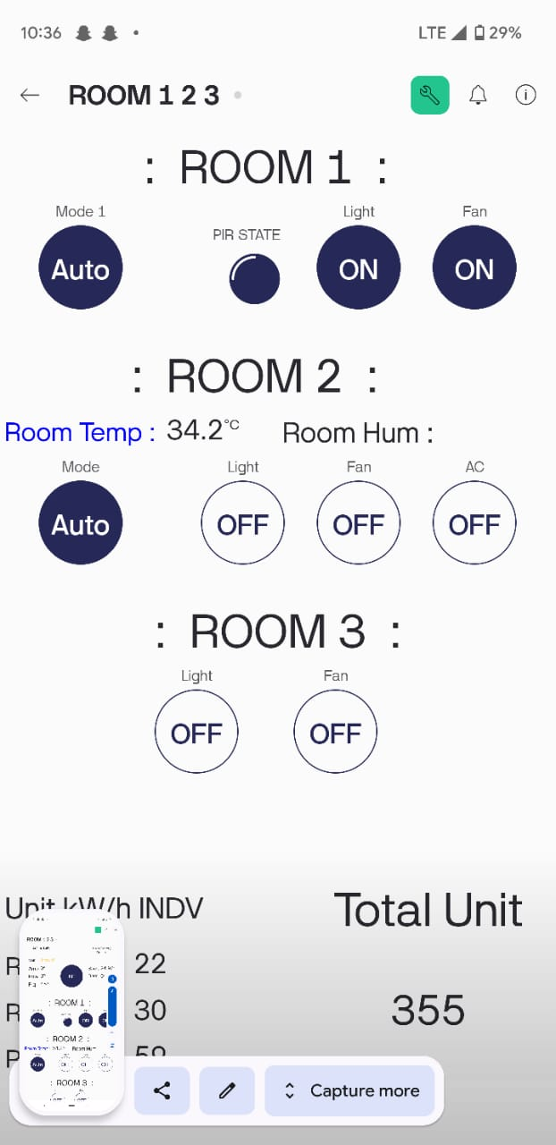

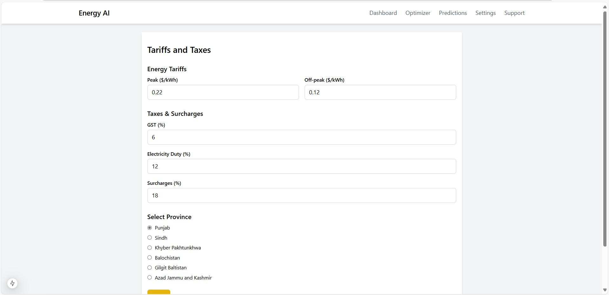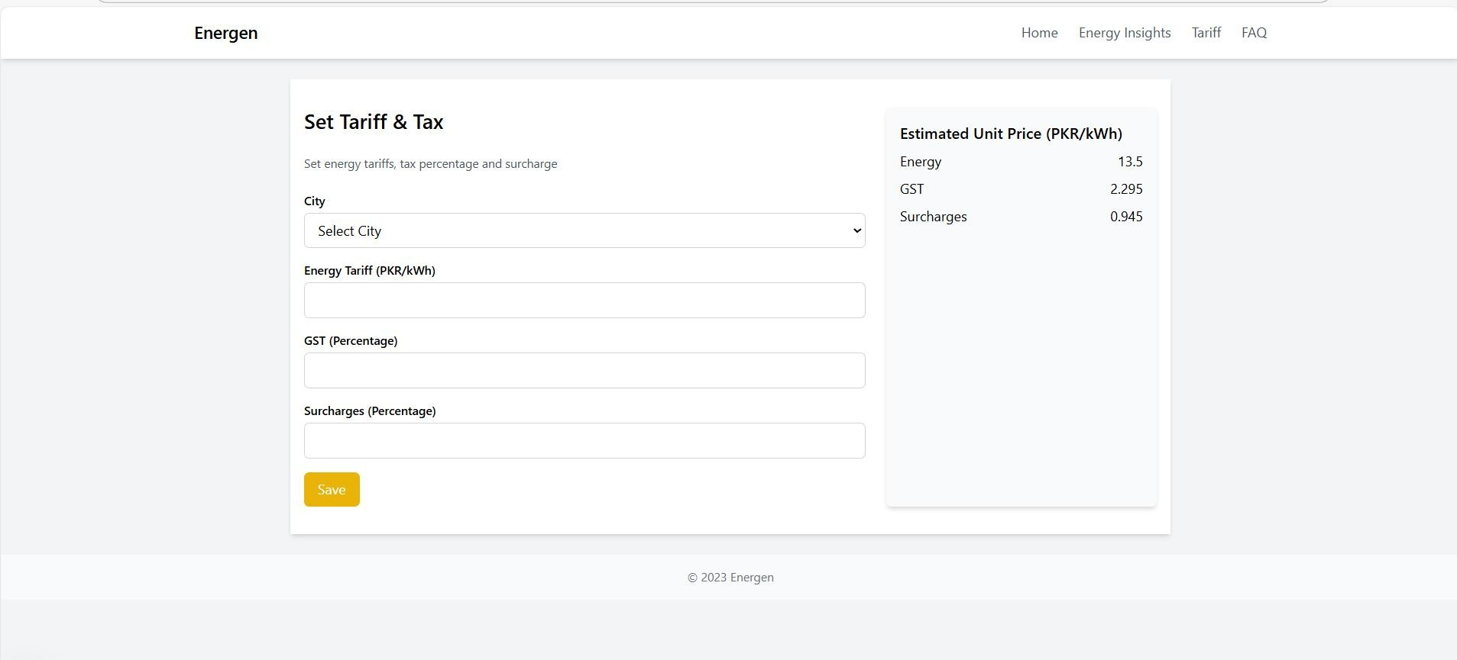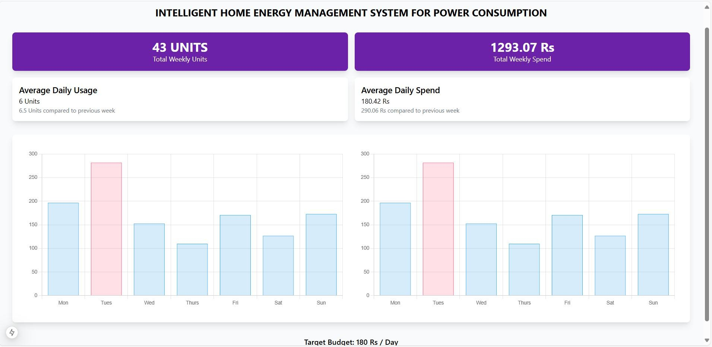

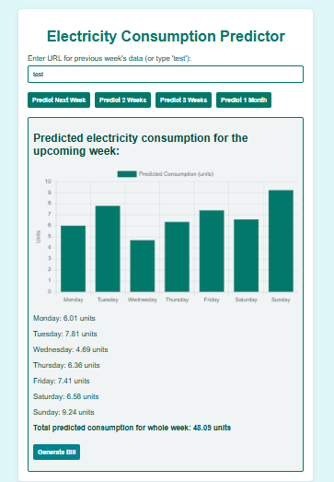

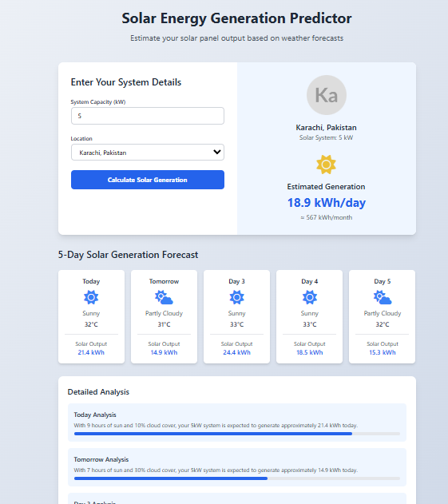

1. **Meetings held with supervisor and/or client.**

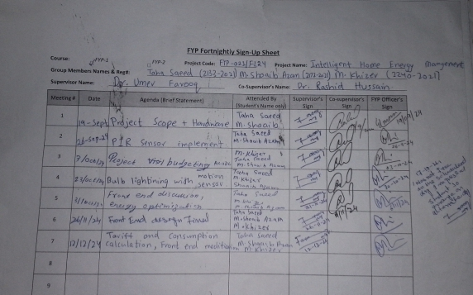

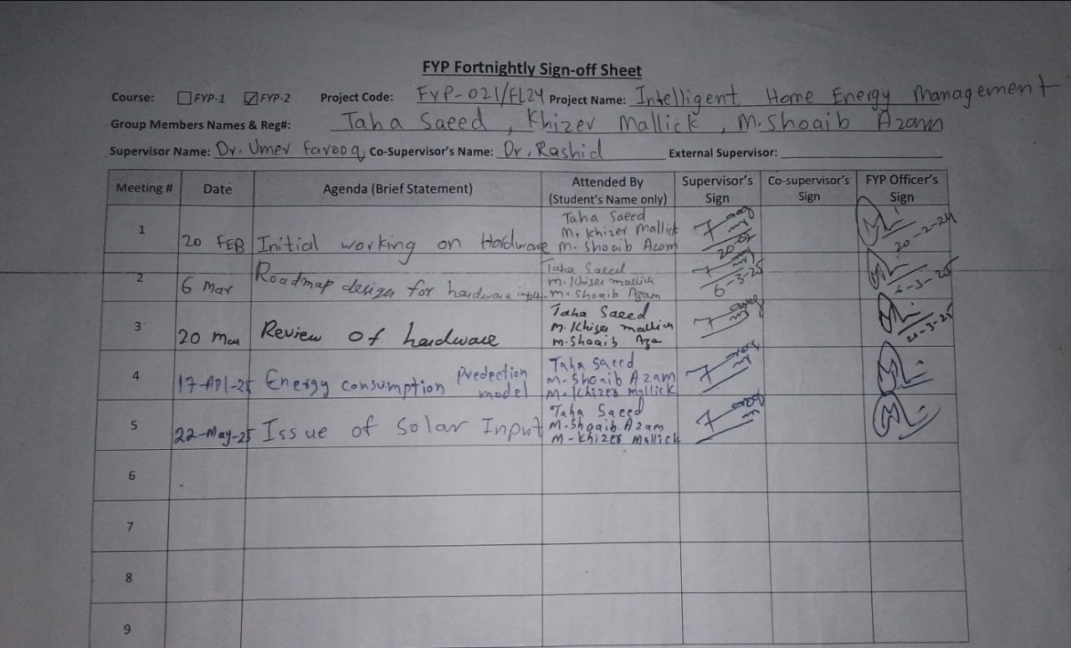

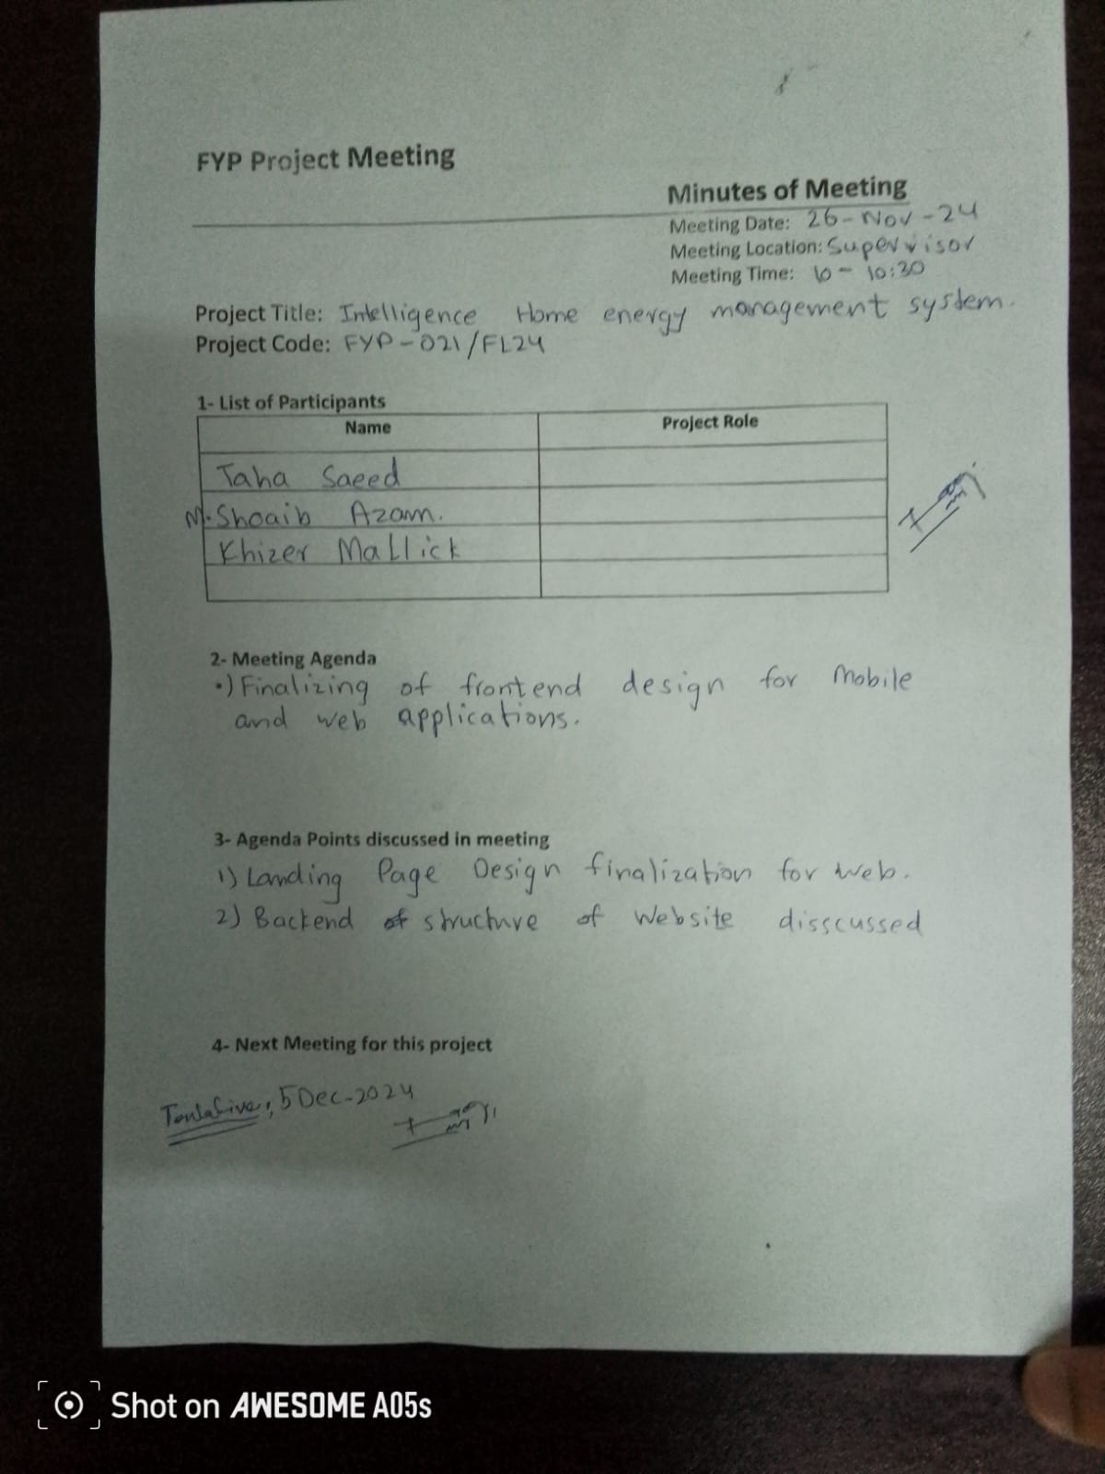

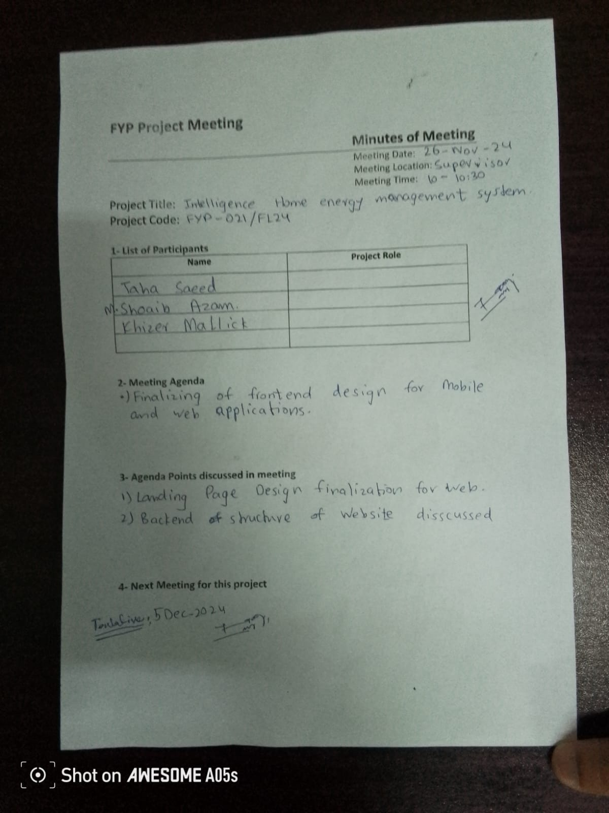

1. **Reference**

### Design and implementation of a Smart Home Energy Management System With Integrated Green Energy Monitoring considering energy saving

* ALiero MS, Qureshi KN, Pasha MF, Jeon G (2021) Smart home energy management systems in Internet of things networks for green cities demands and services. Environ Technol Innov 20:101443
* Mahmoud H Elkholy, Tomonobu Senjyu, Mohammed Elsayed Lotfy, Abdelrahman Elgarhy, Nehad S Ali, Tamer S Gaafar
* Sustainability 14 (21), 13840, 2022

### A smart home energy management system using IoT and big data analytics approach

* Abdul-Rahman Al-Ali, Imran A Zualkernan, Mohammed Rashid, Ragini Gupta, Mazin AliKarar
* IEEE Transactions on Consumer Electronics 63 (4), 426-434, 2017

### Smart home energy management systems: Research challenges and survey

* Ali Raza, Li Jingzhao, Yazeed Ghadi, Muhammad Adnan, Mansoor Ali
* Alexandria Engineering Journal 92, 117-170, 2024

### Smart Energy Management System Using Machine Learning

* Ali Akram, Sagheer Abbas, Muhammad Khan, Atifa Athar, Taher Ghazal, Hussam Al Hamadi
* Computers, Materials & Continua 78 (1), 2024

### A smart home energy management approach incorporating an enhanced northern goshawk optimizer to enhance user comfort, minimize costs, and promote efficient energy consumption

* Heba Youssef, Salah Kamel, Mohamed H Hassan, Juan Yu, Murodbek Safaraliev
* International Journal of Hydrogen Energy 49, 644-658, 2024

### A1B. COPY OF PROPOSAL EVALUATION COMMENTS BY JURY

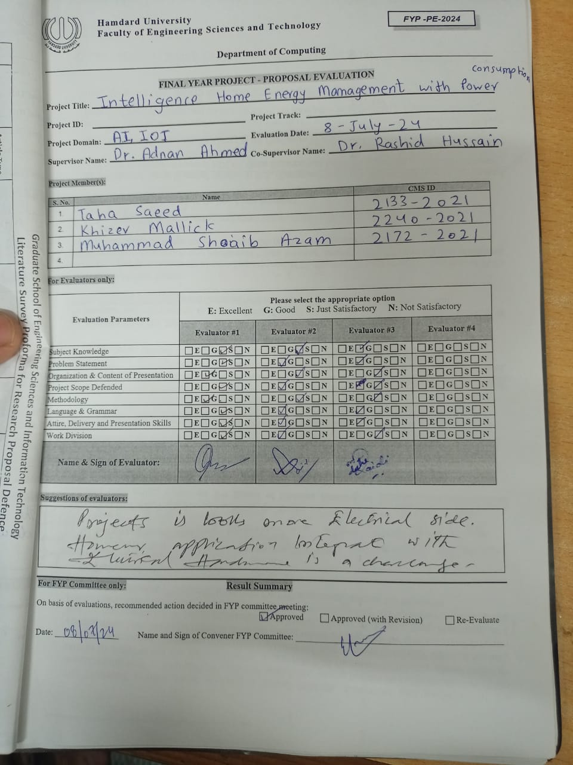

### A2. REQUIREMENT SPECIFICATIONS

Any standard template may be used, as per project need approved by Project Coordinator & Supervisor. Following is a suggestive outline.

1. Introduction
   1. Purpose of Document
   2. Intended Audience

1.3 Abbreviations

1. Overall System Description
   1. Project Background
   2. Project Scope
   3. Not In Scope
   4. Project Objectives
   5. Stakeholders
   6. Operating Environment
   7. System Constraints
   8. Assumptions & Dependencies
2. External Interface Requirements
   1. Hardware Interfaces
   2. Software Interfaces
   3. Communications Interfaces
3. Functional Requirements
   1. Functional Hierarchy
   2. Use Cases
      1. [use case 1]
      2. [use case 2]

4.2.n. [use case n]

1. Non-functional Requirements
   1. Performance Requirements
   2. Safety Requirements
   3. Security Requirements
   4. User Documentation
2. References
3. **Introduction**

### Purpose of Document

The purpose of this Software Requirement Specification (SRS) is to outline the functional, non-functional, and system requirements for the Intelligent Home Energy Management System (IHEMS). The system aims to assist homeowners in monitoring and optimizing their energy consumption to reduce electricity bills and improve efficiency.

###### Intended Audience

This document is intended for:

* + - Project stakeholders and sponsors
    - Development team
    - Quality assurance team
    - End users of the system

###### Abbreviations

* + - IHEMS: Intelligent Home Energy Management System
    - AI: Artificial Intelligence
    - UI: User Interface
    - IoT: Internet of Things

# Overall System Description

* 1. Project Background
  2. Problem Statement
  3. Project Scope
  4. Not In Scope
  5. Project Objectives
  6. Stakeholders & Affected Groups
  7. Operating Environment
  8. System Constraints
  9. Assumptions & Dependencies

### Project Background

The Intelligent Home Energy Management System integrates green energy monitoring and AI- driven analytics to help homeowners optimize energy consumption and reduce electricity bills.

### Problem Statement

Homeowners struggle to manage energy usage effectively, leading to higher bills and grid strain. Existing systems lack real-time monitoring and proactive alerts.

### Project Scope

The IHEMS project will involve the design and development of a smart energy management system that integrates devices and sensors to monitor and control energy usage. It will feature:

* + - Real-time energy monitoring.
    - Alerts and recommendations for optimal energy use.
    - Predictive analytics powered by AI to anticipate future consumption.
    - A user-friendly mobile application for customization and monitoring.

This system will include research, design, implementation, testing, and documentation, with a functional prototype as a deliverable.

### Not In Scope

* + - Integration with commercial energy providers
    - Support for industrial energy management

### Project Objectives

* + - **Energy Monitoring and Management:** Design a system to monitor household electricity usage and provide actionable recommendations to improve efficiency.
    - **Smart Energy Management Alerts:** Notify users when energy consumption exceeds predefined thresholds and recommend corrective actions, including switching to alternative energy sources such as solar or generators.
    - **Predictive Energy Analytics:** Leverage AI to predict future energy consumption based on historical usage patterns, weather data, and solar generation.
    - **User-Friendly Interface:** Develop a customizable and intuitive interface for Android and iOS platforms.

###### Stake holders & Affected Groups

* + - Homeowners
    - Development and QA teams
    - Supervisors: Dr. Umer Farooq and Dr. Rashid Hussain

###### Operating Environment

* + - Hardware: IoT-enabled smart appliances, energy meters, and a central control hub.
    - Software: Mobile app (iOS/Android), and web-based dashboard.
    - Network: Wi-Fi communication.

###### System Constraints

* + - **Hardware:**
      * Sensors and devices like meters, solar panels, and microcontrollers will be used.

###### Software:

* + - * A hybrid development methodology combining Agile and Waterfall will be employed.
      * The system shall be compatible with modern operating systems.

###### Assumptions & Dependencies

* + - Stable internet connectivity is assumed for system operation.
    - Availability of solar panels or alternative energy sources in households.
    - Historical energy data is required for AI-based predictions.

# External Interface Requirements

#### Hardware Interfaces

* + - Sensors: Temperature, energy meters
    - Controllers: Arduino, IoT devices
    - Smart energy meters and IoT-enabled appliances with communication protocols (e.g., Zigbee, Wi-Fi).

#### Software Interfaces

* + - A responsive web and mobile application with dashboards, charts, and control panels.
    - User-friendly navigation and interactive widgets for appliance control.
    - Database: MS SQL
    - Development tools: Visual Studio Code, Python, JavaScript, TensorFlow

#### Communications Interfaces

* + - Wi-Fi for device connectivity
    - Cloud integration for data storage and analysis
    - Secure communication via HTTPS and MQTT protocols.

# System Functions / Functional Requirements

#### System Functions

##### Monitoring:

1. The system shall monitor and log energy consumption in real-time.
2. It shall visualize energy usage through graphical representations.

##### Alerts:

1. Alerts shall be generated when consumption crosses 170, 180, and 190 units.
2. Notifications shall include actionable energy-saving recommendations.

##### Prediction:

1. Predictive models shall forecast future energy consumption.
2. External data sources, such as weather, shall enhance predictions.

##### User Interface:

1. The system shall provide a customizable and user-friendly interface.

2. The app shall support Android and iOS platforms.

|  |  |  |  |  |
| --- | --- | --- | --- | --- |
| **Ref #** | **Functions** | **Category** | **Attribute** | **Details & Boundary Constraints** |
| R1.1 | Monitor real-time energy consumption | Evident | System Response Time | Updates within 2 seconds |
| R1.2 | Provide energy optimization alerts | Evident | Alert Timeliness | Alerts issued within 1 second of threshold breach |
| R1.3 | Predict future energy consumption | Hidden | AI Prediction Accuracy | 90% accuracy based on historical and weather data |
| R1.4 | Switch automatically between energy sources | Evident | System Adaptability | Switch occurs within 3 seconds of condition met |
| R1.5 | Customize user preferences | Evident | User Interface Responsivene ss | Settings updated within 1 second |
|  |  |  |  |  |

##### System Attributes/ Nonfunctional Requirements

1. **Performance:**
   * The system shall handle real-time monitoring with low latency.
   * Predictive models shall respond within acceptable time limits.

##### Reliability:

* + Alerts must be delivered promptly and accurately.
  + The system shall be operational with minimal downtime.

##### Usability:

* + Interfaces shall adhere to accessibility standards.
  + The app shall require minimal user training.

##### Scalability:

* + The system shall support integration with additional smart devices.

|  |  |  |
| --- | --- | --- |
| **Attribute** | **Details and Boundary Constraints** | **Category** |
| Attribute | Details and Boundary Constraints | Category |
| Response Time | Updates must appear within 2 seconds of data collection | Optional |
| Concurrent User Load | Around 20 users can access the system simultaneously | Mandatory |
| Scalability | Supports integration with up to 50 smart devices | Mandatory |
| Data Encryption | All data must be encrypted using AES-256 standard | Mandatory |
| UI Responsiveness | UI changes should take no more than 1 second to reflect | Optional |

* 1. Use Cases





* + - Homeowner
    - System Admin





###### User Registration and Login:

* + Allow new users to register and existing users to log in.

###### User Registration

* + Enables new users to sign up by filling out required details.

###### Select City and Meter Type:

* + Allow users to specify their city and the type of meter (industrial or residential).

###### Manage Tariff Settings:

* + Configure tariffs by including base tariff, fuel adjustment price, and general sales tax.

###### Add Room Details:

* + Allow users to specify the number of rooms and appliances in each room.

###### Solar Energy Monitoring:

* + Display live solar energy sensor readings and future generation predictions.

###### View Dashboard:

* + Provide a detailed overview of current energy usage, predictions for future consumption, and trends.
  + Displays an error message and prevents access when login credentials are invalid.





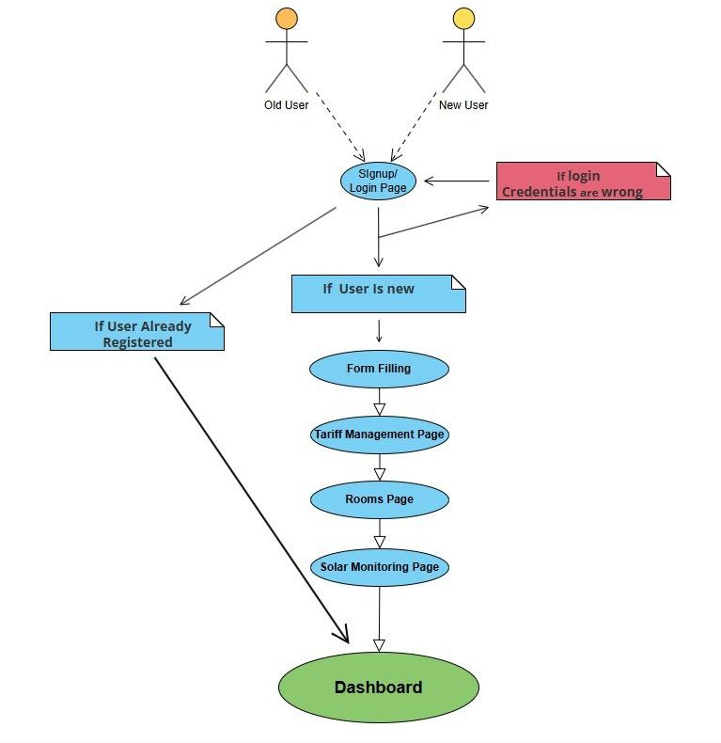

4.2.4 Description of Use Cases

**Use Case 1: User Login**

|  |  |
| --- | --- |
| Name | User Login |
| Actors | Old User, New User |
| Purpose | Allow users to access the system using valid credentials. |
| Description | Users enter their credentials on the login page. If valid, they are redirected to the dashboard. If invalid, they receive an error message prompting them to retry. |
| Cross References | Credential validation, Dashboard access. |
| Pre-Conditions | User must have an account. |
| Successful Post-Conditions | User is redirected to the dashboard. |
| Failure Post- Conditions | Error message is displayed, and the user remains on the login page. |

**Use Case 2: User Registration**

|  |  |
| --- | --- |
| Name | User Registration |
| Actors | New User |
| Purpose | Register new users into the system by gathering required information. |
| Description | New users provide their details via a form to create an account. This data is validated and  stored in the database. |
| Cross References | Form Filling, Database update. |
| Pre-Conditions | User is not already registered. |
| Successful Post-Conditions | User is registered and proceeds to the next step (Tariff Management). |
| Failure Post- Conditions | Registration fails with an error message (e.g., invalid input or system error). |

**Use Case 3: Form Filling**

|  |  |
| --- | --- |
| Name | Form Filling |
| Actors | New User |
| Purpose | Collect necessary details from the user during registration. |
| Description | The system presents a form to the user to gather required details, such as personal  information and preferences. |
| Cross References | User Registration, Database validation. |
| Pre-Conditions | User initiated the registration process. |

|  |  |
| --- | --- |
| Successful Post-Conditions | User details are saved, and the system redirects to the next step (Tariff Management). |
| Failure Post- Conditions | User is prompted to re-enter or correct invalid details. |

**Use Case 4: Tariff Management**

|  |  |
| --- | --- |
| Name | Tariff Management |
| Actors | Old User, New User |
| Purpose | Allow users to manage their energy tariff preferences. |
| Description | Users select or configure their preferred energy tariff plans. |
| Cross References | Dashboard, Solar Monitoring. |
| Pre-Conditions | User completed the form filling process. |
| Successful Post-Conditions | Tariff details are saved, and the system proceeds to the Rooms Page. |
| Failure Post- Conditions | Error message displayed; user retries tariff configuration. |

**Use Case 5: Room Configuration**

|  |  |
| --- | --- |
| Name | Room Configuration |
| Actors | Old User, New User |
| Purpose | Enable users to configure their rooms for energy usage tracking. |
| Description | Users define the setup and preferences for energy management in individual rooms. |
| Cross References | Solar Monitoring, Dashboard. |
| Pre-Conditions | User completed the form filling process. |
| Successful Post-Conditions | Room configuration details are saved, and the system proceeds to the Solar Monitoring page. |
| Failure Post- Conditions | Error message displayed; user retries configuration. |

**Use Case 6: Solar Monitoring Setup**

|  |  |
| --- | --- |
| Name | Solar Monitoring Setup |
| Actors | Old User, New User |
| Purpose | Allow users to integrate and monitor solar energy usage. |
| Description | Users configure solar monitoring preferences and view solar energy statistics. |
| Cross References | Dashboard, Room Configuration. |

|  |  |
| --- | --- |
| Pre-Conditions | User completed room configuration. |
| Successful Post-Conditions | Solar monitoring preferences are saved, and the user is redirected to the dashboard. |
| Failure Post- Conditions | Error message displayed; user retries configuration. |

**Use Case 7: Dashboard Access**

|  |  |
| --- | --- |
| Name | Dashboard Access |
| Actors | Old User, New User |
| Purpose | Provide users with a central interface for managing energy systems. |
| Description | The dashboard displays energy statistics, solar monitoring, tariff details, and room configurations. Users can navigate to various  sections from here. |
| Cross References | Login, Tariff Management, Solar Monitoring. |
| Pre-Conditions | User has successfully logged in or completed the registration process. |
| Successful Post-Conditions | User can view and manage system details via the dashboard. |
| Failure Post- Conditions | N/A (Dashboard is accessible only after meeting pre-conditions). |

**Typical Course Event:**

|  |  |
| --- | --- |
| **Actor Action** | **System Response** |
| **The user enters login credentials.** | The system validates the credentials. |
| **The user clicks the "Login" button.** | If valid, the system redirects the user to the dashboard. If invalid, an error message is displayed. |

|  |  |
| --- | --- |
| **Actor Action** | **System Response** |
| **The user navigates to the "Signup" page.** | The system displays a form for user details. |
| **The user fills out the registration form.** | The system validates the input data. |
| **The user clicks the "Register" button.** | If valid, the system creates a new account and redirects to the next step (Form Filling). If invalid, an error message is displayed. |
| **The user fills out personal and required details.** | The system validates the form data. |
| **The user clicks the "Submit" button.** | If valid, the system saves the details and proceeds to the Tariff Management page. If invalid, the system prompts the user to correct the errors. |
| **The user selects or configures a tariff plan.** | The system validates the selected plan. |
| **The user clicks the "Save" button.** | If valid, the system saves the preferences and redirects to the Rooms Page. If invalid, an error message is displayed. |
| **The user configures rooms for energy usage tracking.** | The system collects and validates the configuration data. |

|  |  |
| --- | --- |
| **Actor Action** | **System Response** |
| **The user clicks the "Save" button.** | If valid, the system saves the room configurations and redirects to the Solar Monitoring page. If invalid, an error message is displayed. |
| **The user configures solar monitoring settings.** | The system validates the settings and prepares the monitoring dashboard. |
| **The user clicks the "Save" button.** | If valid, the system saves the settings and redirects the user to the dashboard. If invalid, an error message is displayed. |
| **The user logs in or completes registration.** | The system displays the dashboard interface. |
| **The user navigates through the dashboard.** | The system provides access to energy statistics, tariff details, and solar monitoring configurations |

# Non - Functional Requirements

* 1. Performance Requirements
  2. Safety Requirements
  3. Security Requirements
  4. Reliability Requirements
  5. Usability Requirements
  6. Supportability Requirements
  7. User Documentation

#### Performance Requirements

* + - The system must process real-time data with a delay of less than 2 seconds.
    - The system shall handle real-time monitoring with low latency.
    - Predictive models shall respond within acceptable time limits.

##### Safety Requirements

* + - Ensure no data breaches or unauthorized access to user data.

##### Security Requirements

* + - Encrypt all sensitive data.

##### Reliability Requirements

* + - Alerts must be delivered promptly and accurately.
    - The system shall be operational with minimal downtime.

##### Usability Requirements

* + - Interfaces shall adhere to accessibility standards.
    - The app shall require minimal user training.

##### Supportability Requirements

* + - Ensure system updates can be deployed seamlessly.

##### User Documentation

* + - Comprehensive user manual and training materials.

# REFERENCES

###### Design and implementation of a Smart Home Energy Management System With Integrated Green Energy Monitoring considering energy saving

* + - ALiero MS, Qureshi KN, Pasha MF, Jeon G (2021) Smart home energy management systems in Internet of things networks for green cities demands and services. Environ Technol Innov 20:101443
    - Mahmoud H Elkholy, Tomonobu Senjyu, Mohammed Elsayed Lotfy, Abdelrahman Elgarhy, Nehad S Ali, Tamer S Gaafar
    - Sustainability 14 (21), 13840, 2022

###### A smart home energy management system using IoT and big data analytics approach

* + - Abdul-Rahman Al-Ali, Imran A Zualkernan, Mohammed Rashid, Ragini Gupta, Mazin AliKarar
    - IEEE Transactions on Consumer Electronics 63 (4), 426-434, 2017

###### Smart home energy management systems: Research challenges and survey

* + - Ali Raza, Li Jingzhao, Yazeed Ghadi, Muhammad Adnan, Mansoor Ali
    - Alexandria Engineering Journal 92, 117-170, 2024

###### Smart Energy Management System Using Machine Learning

* + - Ali Akram, Sagheer Abbas, Muhammad Khan, Atifa Athar, Taher Ghazal, Hussam Al Hamadi
    - Computers, Materials & Continua 78 (1), 2024

###### A smart home energy management approach incorporating an enhanced northern goshawk optimizer to enhance user comfort, minimize costs, and promote efficient energy consumption

* + - Heba Youssef, Salah Kamel, Mohamed H Hassan, Juan Yu, Murodbek Safaraliev
    - International Journal of Hydrogen Energy 49, 644-658, 2024

### A3. DESIGN SPECIFICATIONS

Any standard template may be used, as per project need approved by Project Coordinator & Supervisor. Following is a suggestive outline.

1. Introduction
   1. Purpose of Document
   2. Intended Audience
   3. Project Overview
   4. Scope
2. Design Considerations
   1. Assumptions and Dependencies
   2. Risks and Volatile Areas
3. System Architecture
   1. System Level Architecture
   2. Software Architecture
4. Design Strategy
5. Detailed System Design
   1. Database Design
      1. ER Diagram
      2. Data Dictionary
         1. Data 1
         2. Data 2
         3. Data n
   2. Application Design
      1. Sequence Diagram
         1. <Sequence Diagram 1>
         2. <Sequence Diagram 2>
         3. <Sequence Diagram n>
      2. State Diagram
         1. <State Diagram 1>
         2. <State Diagram 2>

5.2.2.n <State Diagram n>

1. References

# Introduction

## Purpose of Document

This document outlines the design and specifications for developing an Intelligent Home Energy Management System (IHEMS) aimed at monitoring and optimizing energy consumption. It details the architectural framework, design considerations, and implementation strategies to ensure the system meets functional and non- functional requirements.

## Intended Audience

The primary audience includes:

* **Project Team Members**: Developers, testers, and designers working on the project.
* **Supervisors**: Dr. Umer Farooq and Dr. Rashid Hussain for project oversight.
* **Stakeholders**: Homeowners, researchers, and industry professionals interested in smart energy solutions.
* **Evaluators**: Faculty and committee members at Hamdard University.

## Document Convention

The document uses the following conventions:

* **Font**: Times New Roman
* **Font Size**: 12pt for text, 14pt for headings.
* **Spacing**: Single-spaced.

## Project Overview

The IHEMS project aims to develop a smart home energy management system that leverages sensors, AI algorithms, and user-friendly interfaces. The system monitors real-time energy consumption, provides predictive analytics, and recommends optimization strategies. It also switches to alternate energy sources when consumption exceeds predefined thresholds

## Scope

The project involves the design and development of:

* Real-time energy consumption monitoring.
* AI-driven predictive analytics for consumption trends.
* Smart notifications for energy-saving measures.
* Integration of alternative energy sources (solar, generator).
* A user-friendly web/mobile application for Android

# Design Considerations

## Assumptions and Dependencies

Dependence on accurate and real-time sensor data for effective monitoring. Availability of reliable network connectivity for real-time updates.

Dependence on the user's willingness to adopt energy-saving recommendations.

## Risks and Volatile Areas

**Technological Risks**: Sensor inaccuracies, network failures.

**Regulatory Risks**: Compliance with local energy usage regulations.

### Change Risks: Evolving user requirements or updates in mobile OS standards

# System Architecture

The system is decomposed into the following major subsystems:

## System Level Architecture

1. **User Interaction Layer**: Handles user input and output. This includes pages like login, signup, form filling, and dashboard visualization.
2. **Tariff Management Subsystem**: Processes energy-related pricing, including base tariffs, fuel adjustment prices, and taxes.
3. **Room and Appliance Configuration Subsystem**: Captures details about the user's home, including the number of rooms and appliances per room.
4. **Solar Generation Subsystem**: Manages live sensor readings and future solar energy predictions.
5. **Dashboard Subsystem**: Displays real-time usage and future consumption predictions based on user data and system calculations.

**Relationships Between Components**

* + The User Interaction Layer communicates directly with the Room Configuration, Tariff Management, and Solar Generation Subsystems to capture input and display output.
  + The Tariff Management Subsystem uses external data (e.g., general sales tax and fuel adjustment prices) to calculate energy costs.
  + The Solar Generation Subsystem interacts with hardware sensors for live readings and prediction algorithms.
  + The Dashboard Subsystem aggregates information from all other components and presents it visually to the user.

### Interfaces to External Systems

* + **Tariff Management** connects to external databases for tariff data and tax regulations.
  + **Solar Generation** interfaces with IoT devices and sensors.

### Major Physical Design Issues

* + The **User Interface Layer** will execute on client devices (web or mobile).
  + The **Middle Layer** (business logic) and **Data Layer** will execute on a central server.

### Global Design Strategies

* + **Error Handling**: Centralized error logging with real-time notifications for critical failures.
  + **Security**: Authentication for login/signup and data encryption for sensitive information.
    - * 1. 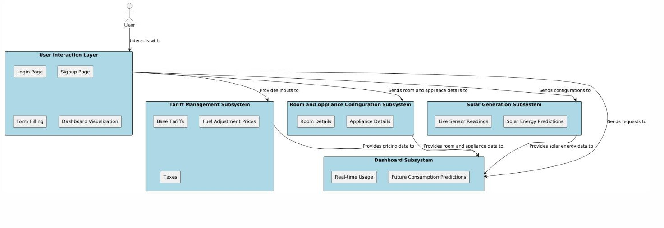

## Software Architecture

The software architecture is layered as follows:

### User Interface Layer

* **Description**: This layer includes the login, signup, form filling, and dashboard pages. It collects user input and displays results.
* **Technology**: Web frameworks (e.g., React, Angular) or mobile frameworks (e.g., Flutter).

### Middle Tier (Business Logic Layer)

* **Description**: Processes inputs from the user interface and manages the interactions between subsystems.

### Modules:

* + Tariff calculations
  + Room configuration logic
  + Solar energy predictions
* **Technology**: Server-side frameworks (e.g., Node.js, Django, or Spring Boot).

### Data Access Layer

* **Description**: Interfaces with the database to store and retrieve user details, tariff data, room configurations, and solar readings.
* **Technology**: Relational databases (e.g., MySQL, PostgreSQL) or NoSQL databases (e.g., MongoDB).

### Layer Interaction Diagram

- The interaction between layers can be visualized as:

1. User requests (e.g., tariff settings) sent from the User Interface Layer.
2. Requests processed by the Middle Tier.
3. Data retrieved or stored via the Data Access Layer.

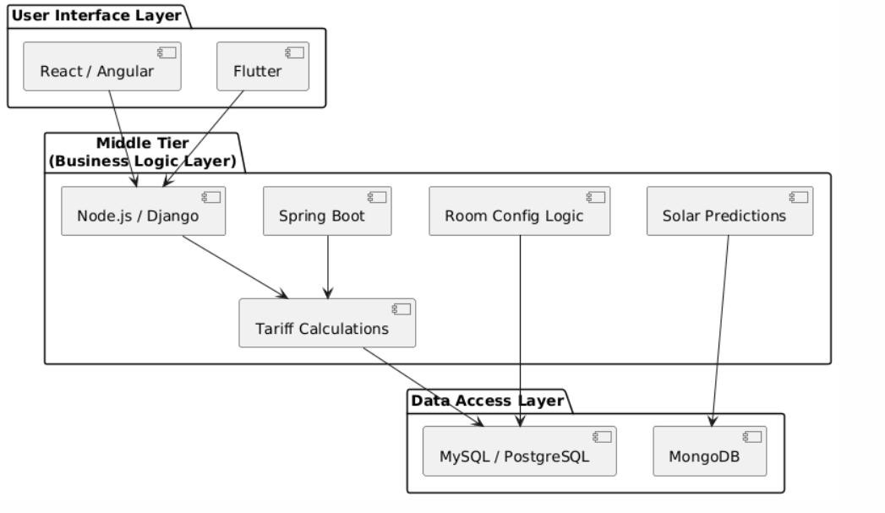

# Design Strategy

### Future System Extension or Enhancement

* **Modularity**: **Future System Extension/Enhancement**
  + **Modularity**: Independent subsystems enable seamless feature addition (e.g., smart appliances).
  + **Scalability**: Architecture supports high user loads effectively.

### System Reuse

* + Components like Solar Generation and Tariff Management can be reused in other systems.

### User Interface Paradigms

* + **Intuitive Design**: Simple interface for all users.
  + **Real-Time Feedback**: Dashboard shows live energy updates.

### Data Management

* **Storage**: Relational DB for structured data, NoSQL for unstructured sensor data.
  + **Distribution**: Real-time sync between UI and server.
  + **Persistence**: Historical data maintained for analysis.

### Concurrency and Synchronization

* + **Concurrency**: Supports multiple simultaneous users.
  + **Synchronization**: Locking ensures data integrity during updates

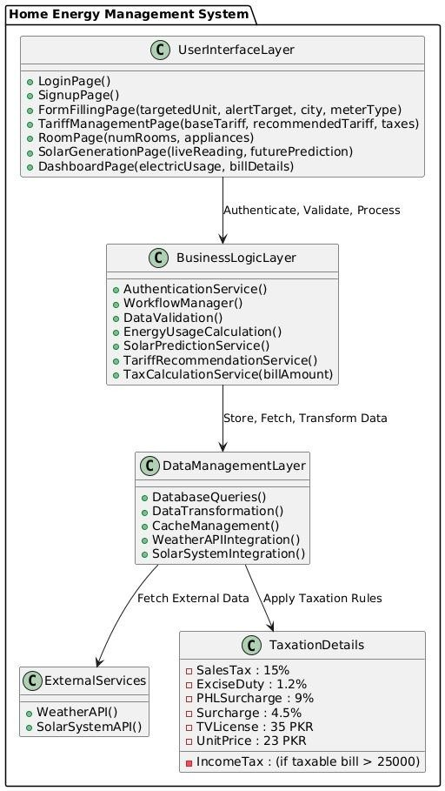

# Detailed System Design

## Design Class Diagram

* Provides a detailed class diagram.
* Attributes, methods, and interactions between classes are described.
* Logical data models (e.g., E/R models) are included.

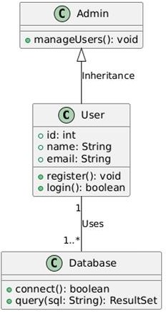

## Database Design

**User Singup**

|  |  |  |  |  |
| --- | --- | --- | --- | --- |
| **id** | **username** | **password** | **email** | **created_at** |
| 1 | testuser | hashed_password | [testuser@example.com](mailto:testuser@example.com) | 2025-01-12 12:00:00 |

**Form filling**

|  |  |  |  |  |
| --- | --- | --- | --- | --- |
| **id** | **targeted_unit_use** | **city** | **meter_type** | **created_at** |
| 1 | 200. | Karachi | Residential | 2025-01-12 12:00:00 |
| 2 | 350 | Karachi | Industrial | 2025-01-12 12:00:00 |
| 3 | 250. | Karachi | commercial | 2025-01-12 12:00:00 |

**Terrif calculation**

|  |  |  |  |  |  |  |
| --- | --- | --- | --- | --- | --- | --- |
| **Selected**  **City** | **Sales.**  **tax** | **Exercise**  **duty.** | **PHL**  **Surcharge** | **Surcharge** | **TV**  **License** | **Price of**  **per unit** |
| Karachi | 15%. | 1.2% | 9% | 4.5% | 35 pkr. | 23 |

### Room. No of Appliance

Room 1 3

### Room Appliances

### Room1

|  |  |  |  |  |  |  |
| --- | --- | --- | --- | --- | --- | --- |
| **Appliance 1** | **Estimated Usage (hours/day**  **)** | **Appliance 2** | **Estimated Usage (hours/day**  **)** | **Appliance 3** | **Estimated Usage (hours/day**  **)** | **Daily Usage (kWh)** |
| Bulb | 5 | Fan | 6 | AC | 1 | 8 |

**Room2**

|  |  |  |  |  |  |  |
| --- | --- | --- | --- | --- | --- | --- |
| **Appliance 1** | **Estimated Usage (hours/day**  **)** | **Appliance 2** | **Estimated Usage (hours/day**  **)** | **Appliance 3** | **Estimated Usage (hours/day**  **)** | **Daily Usage (kWh)** |
| Bulb | 5 | Fan | 6 | Refrigerato r | 14 | 15 |

|  |  |  |  |
| --- | --- | --- | --- |
| **Solar**  **Date** | **Live (kWh) Generation.** | **Predicted Generation.** | **Weather Condition** |
|  | **(kWh).** | **(kWh)** |  |
| 2025-01-12 | 150 | 180 | Sunny |
| 2025-01-12 | 150 | 180 | Sunny |
| 2025-01-13 | 130 | 155. | Partly Cloudy |

**Average Daily Usage and Weekly Cost**

|  |  |
| --- | --- |
| **Metric** | **Value** |
| Average Daily Usage (units). | 6.5 |
| Weekly Consumption (units) | 45 |
| Cost per Unit (Rupees) | 24 |
| Weekly Cost (Rupees) | 1080 |

**Weekly Consumption Breakdown**

|  |  |
| --- | --- |
| **Day Units.**  **Consumed** | **Cost (Rupees)** |
| Sunday 7.5. | 156 |
| Monday 6.0 | 156 |
| Tuesday 6.0 | 156 |
| Wednesday 6.5 | 156 |
| Thursday 5.5. | 156 |
| Friday 6.5 | 156 |
| Saturday 7.0 | 156 |

### 

### ER Data Model

### Entities:

User: Attributes: login_id, Password, Name, Phone_number, Email

Tariff: Attributes: Tariff_id, sales_tax, exercise_duty, PHL_surcharge, Surcharge, TV_license, Price_per_unit

Meter: Attributes: Meter_id, Industrial Meter_id, Commercial Meter_id, Residential Meter_id, target_unit, City_id

Room: Attributes: Room_id, No_of_Appliances SolarSystem: Attributes: Solar_id, Live_reading, Prediction

Dashboard: Attributes: Previous_week_consumption_id, Previous_week_usage, Current_reading_id, Future_bill_prediction_id

**Relationships:**

User ↔ Tariff: One-to-many (One user can have multiple tariffs based on usage) Meter ↔ User: Many-to-one (Multiple meters are linked to a single user)

Room ↔ Meter: Many-to-one (Rooms are linked to a specific meter)

SolarSystem ↔ Dashboard: One-to-one (Live readings are linked directly to dashboard details)

**Data Dictionary**

**Data 1: User Information**

**Attributes:**

login_id: Primary Key, INT

Password: VARCHAR

Name: VARCHAR

Phone_number: VARCHAR

Email: VARCHAR

Description: Stores user credentials and personal details for login and signup purposes.

### Data: Tarrif Information Attributes:

Tariff_id: Primary Key, INT sales_tax: VARCHAR exercise_duty: VARCHAR PHL_surcharge: VARCHAR Surcharge: VARCHAR TV_license: VARCHAR Price_per_unit: VARCHAR

Description: Stores tariff details for different user categories

### Data: Meter Information Attributes:

Meter_id: Primary Key, INT Industrial Meter_id: INT Commercial Meter_id: INT Residential Meter_id: INT target_unit: INT

City_id: INT

Description: Stores meter-specific information related to industrial, commercial, and residential users.

### Data: Room and Appliance Details Attributes:

Room_id: Primary Key, INT No_of_Appliances: VARCHAR

Description: Captures the number of rooms and appliances per room

### Data: Solar System Attributes:

Solar_id: Primary Key, INT Live_reading: VARCHAR Prediction: VARCHAR

Description: Manages live readings and predictions related to solar energy.

### Data: Dashboard

**Attributes:** Previous_week_consumption_id: INT Previous_week_usage: INT Current_reading_id: INT Future_bill_prediction_id: INT

Description: Displays real-time consumption and historical data

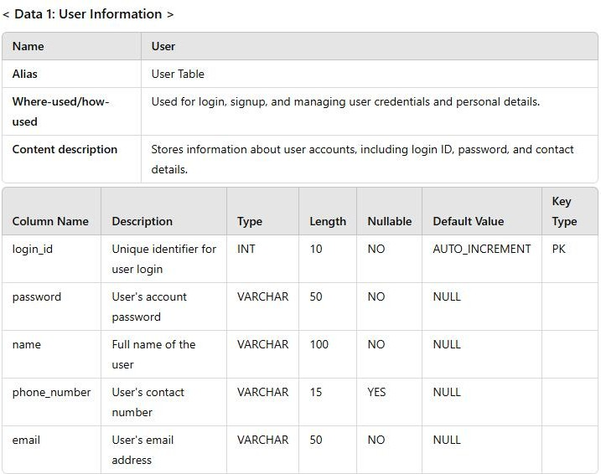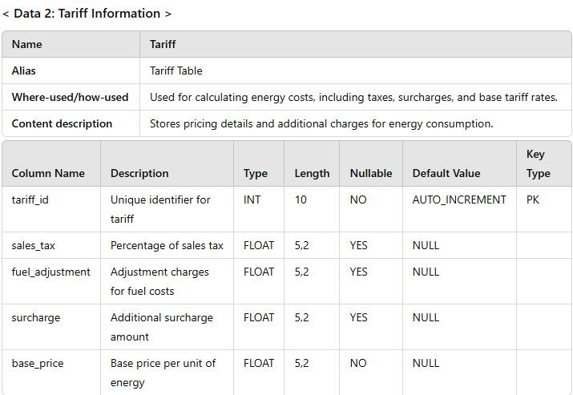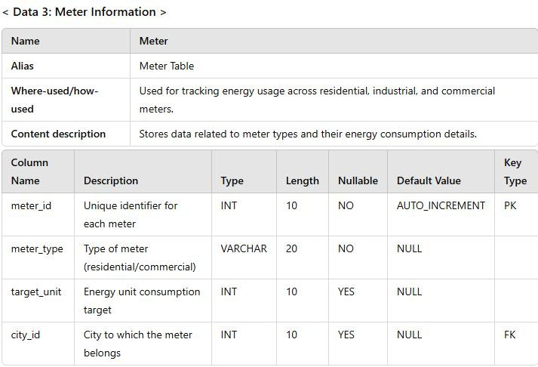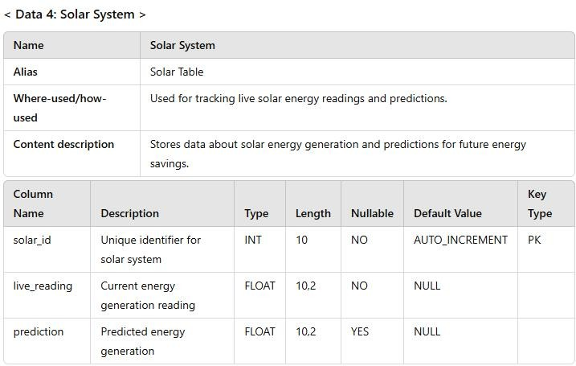

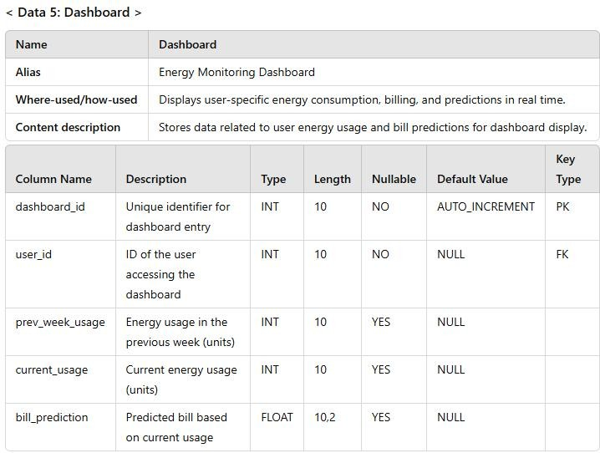

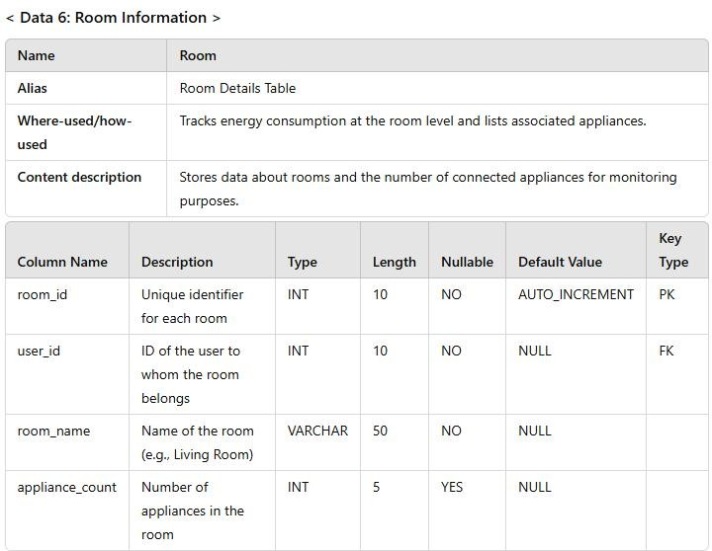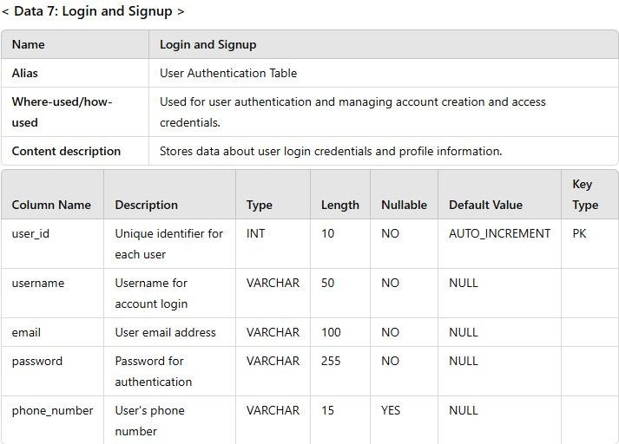

*The notation to develop content description is given below:*

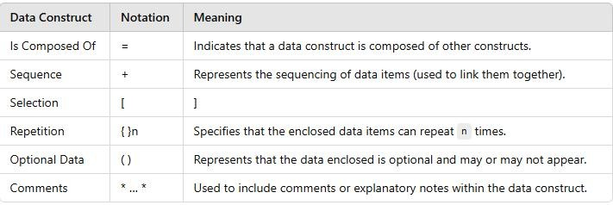

## Application Design

This section focuses on system workflows and interaction.

**Sequence Diagram**

* Illustrates object interactions over time.
* Each diagram includes explanations.

### <Sequence Diagram 1> Diagram Explanation:

This diagram represents the flow of interactions during a user registration process in an

application. The main components include the User, Frontend, Backend, and Database. The steps include:

1. **User Input:** The User provides registration details via the frontend.
2. **Validation:** The Frontend sends data to the Backend for validation.
3. **Database Check:** The Backend checks the Database for duplicate entries.
4. **Save User Data:** If no duplicates are found, the Backend saves the user's data in the Database.
5. **Response to User:** Confirmation is sent back to the Frontend and displayed to the User.

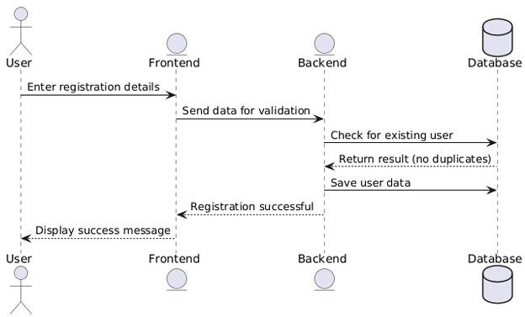

### <Sequence Diagram 2>

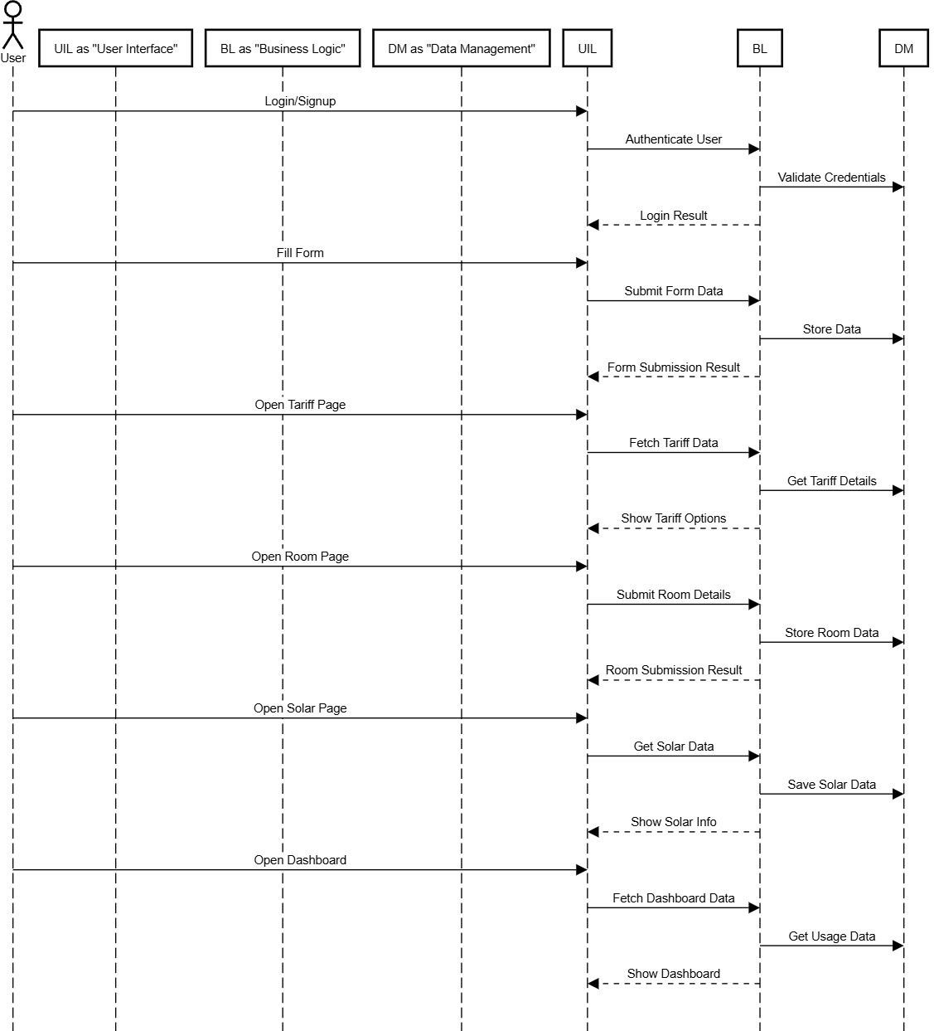.

.

**State Diagram**

### 

**<State Diagram 2>**

*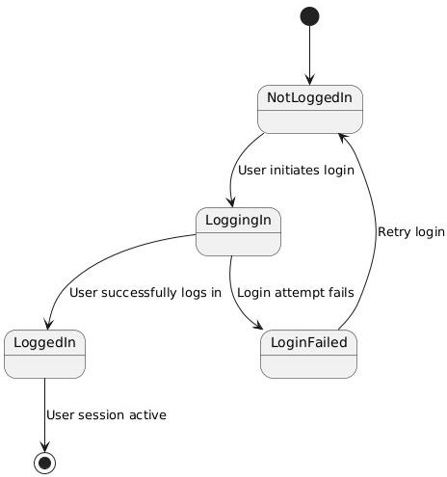[Diagram & Explanation of diagram]*

.

## GUI Design

******<Sign Up - Mock Screen 1>**

**<Login - Mock Screen 2>**

.. 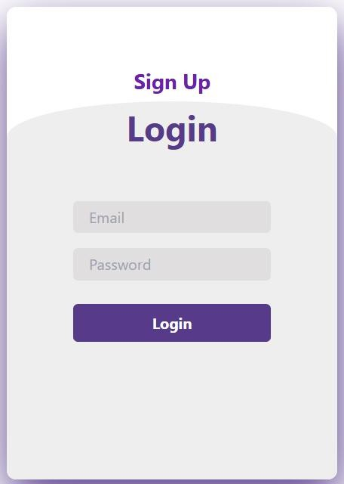

******<Dashboard - Mock Screen 3>**

**<Tarrifs- Mock Screen 3>**



******<Set Tarrifs and Taxes- Mock Screen 3>**

# References

### [Design and implementation of a Smart Home Energy Management System With Integrated Green Energy Monitoring considering energy saving

* ALiero MS, Qureshi KN, Pasha MF, Jeon G (2021) Smart home energy management systems in Internet of things networks for green cities demands and services. Environ Technol Innov 20:101443
* Mahmoud H Elkholy, Tomonobu Senjyu, Mohammed Elsayed Lotfy, Abdelrahman Elgarhy, Nehad S Ali, Tamer S Gaafar
* Sustainability 14 (21), 13840, 2022

### A smart home energy management system using IoT and big data analytics approach

* Abdul-Rahman Al-Ali, Imran A Zualkernan, Mohammed Rashid, Ragini Gupta, Mazin AliKarar
* IEEE Transactions on Consumer Electronics 63 (4), 426-434, 2017

### Smart home energy management systems: Research challenges and survey

* Ali Raza, Li Jingzhao, Yazeed Ghadi, Muhammad Adnan, Mansoor Ali
* Alexandria Engineering Journal 92, 117-170, 2024

### Smart Energy Management System Using Machine Learning

* Ali Akram, Sagheer Abbas, Muhammad Khan, Atifa Athar, Taher Ghazal, Hussam Al Hamadi
* Computers, Materials & Continua 78 (1), 2024
* **A smart home energy management approach incorporating an enhanced northern goshawk optimizer to enhance user comfort, minimize costs, and promote efficient energy consumption**
* Heba Youssef, Salah Kamel, Mohamed H Hassan, Juan Yu, Murodbek Safaraliev
* International Journal of Hydrogen Energy 49, 644-658, 2024

# Appendices

### Glossary of Terms

* **User Interface (UI):** The visual component of the system through which users interact with the software.
* **Solar Prediction Algorithm:** A mechanism that forecasts solar energy generation based on historical and real-time data.
* **Tariff Management System:** A subsystem that calculates energy pricing based on different tariffs, taxes, and adjustments.

### Code Snippets

Include important code snippets used in the project. For example:

* Example API integration.
* Database connection logic.
* A key algorithm (e.g., solar prediction calculation).

### Data Dictionary

* Include detailed tables outlining all data attributes, their types, relationships, and constraints (refer to the tables created earlier).

### Tools and Technologies

List the tools and technologies used in the project:

* Programming Languages: Python, JavaScript.
* Frameworks: Django, React.
* Databases: MySQL, MongoDB.
* Others: Docker, Postman, Git.

### Diagrams and Models

Include high-level architecture diagrams, UML diagrams, ER diagrams, and any additional visual representations relevant to the project.

### Testing Documentation

* Testing Plan: Include details of test cases executed.
* Results: Provide a summary of the testing phase, such as performance and bug fixes.

### Project Timeline

Provide a Gantt chart or a detailed timeline showing the project's phases and milestones.

### References

List all sources of information used in your project:

* Research papers.
* Online articles.
* Technical documentation

### Future Work

Highlight potential future enhancements to the system, such as:

* Integration with IoT-based appliances.
* Advanced AI algorithms for better prediction accuracy.
* Multi-lingual support for the user interface.

### User Manual

Provide a step-by-step guide for end-users to navigate and use the system, including screenshots where applicable.

### A4. OTHER TECHNICAL DETAIL DOCUMENTS

### Test Cases Document

### Software Test Plan

| S. No | Screen/Report Name | Test Engineer | Start Date | End Date |
| --- | --- | --- | --- | --- |
| 1 | App Login Screen | Khizer | 01-Jul-2025 | 01-Jul-2025 |
| 2 | Manual Appliance Control | Khizer | 01-Jul-2025 | 01-Jul-2025 |
| 3 | Sensor-Based Auto Control | Taha | 02-Jul-2025 | 02-Jul-2025 |
| 4 | Time-Based Appliance Schedule | Taha | 02-Jul-2025 | 02-Jul-2025 |
| 5 | Real-Time Energy Monitoring | Khizer | 03-Jul-2025 | 03-Jul-2025 |
| 6 | Daily Consumption Summary | Shoaib | 03-Jul-2025 | 03-Jul-2025 |
| 7 | Smart Decision Logic | Shoaib | 04-Jul-2025 | 04-Jul-2025 |
| 8 | Solar Optimization Logic | Taha | 04-Jul-2025 | 04-Jul-2025 |
| 9 | Appliance Toggle via App | Taha | 05-Jul-2025 | 05-Jul-2025 |
| 10 | Grid Failure Backup Switch | Shoaib | 05-Jul-2025 | 05-Jul-2025 |

### Test Case (for screens/reports)

| TC No. | Steps | Input Data | Expected Result | Actual Result | Pass/Fail |
| --- | --- | --- | --- | --- | --- |
| TC-01 | Tap ON button for light | "Living Room Light" → ON | Light turns ON, UI updates status | Light turned ON, UI OK | Pass |
| TC-02 | No motion detected for 10 min | PIR = No motion | AC turns OFF, log entry created | AC turned OFF, log OK | Pass |
| TC-03 | Time-based schedule activates heater | Time = 06:00 AM | Water heater turns ON | Heater turned ON | Pass |
| TC-04 | Monitor current energy usage | Sensor = 250W | UI displays "Current Usage: 250W" | Display correct | Pass |
| TC-05 | View daily consumption summary | Usage logs (last 24h) | Summary = "12.4 kWh used" | Summary visible | Pass |
| TC-06 | Detect peak hours and load > 2kW | Time = 6 PM, Load = 2.5kW | TV/Charger OFF, Fridge ON | Devices managed | Pass |
| TC-07 | Use solar when available | Solar = 800W, Battery = 60% | Devices powered via solar+bat, grid reduced | Grid minimized | Pass |
| TC-08 | User logs in with valid credentials | Valid email and password | Redirect to dashboard | Dashboard opened | Pass |
| TC-09 | User toggles fan OFF from app | Tap OFF button | Fan turns OFF, UI status = OFF | Fan turned OFF | Pass |
| TC-12 | Grid power fails, system switches to battery | Grid = 0V | Switch to battery, log shows failover | Battery active, log OK | Pass |

### UI/UX Detail Document

### 1. Design Approach

### Minimalist & Intuitive: The interface is simple, with essential controls like ON/OFF toggles, status indicators, and energy usage graphs.

### Responsive Layout: Designed to work on both mobile (Blynk App) and web interfaces.

### Color Scheme: Green for active devices, red for OFF, blue for standby. Graphs use light backgrounds with colored lines.

### User Interface Components

| Screen | Features |
| --- | --- |
| Login Screen | Email & password input, forgot password option |
| Dashboard | Appliance status (ON/OFF), energy usage (real-time), system alerts |
| Device Control | Toggle buttons for appliances, schedules, thresholds |
| Energy Analytics | Daily/weekly usage graphs, peak-hour indicators |
| Settings | Notification preferences, time-based rules, manual override |

### User Experience Goals

### Quick access to device control

### Real-time feedback from sensors

### Simple navigation and minimal clicks

### Coding Standards Document

### Languages Used

### Microcontroller Code: Arduino (C++)

### Web/App Interface: JavaScript (for web), Blynk template (for mobile)

### Naming Conventions

### Variables: camelCase (currentReading, relayStatus)

### Constants: UPPER_SNAKE_CASE (MAX_THRESHOLD)

### Functions: Descriptive and camelCase (readCurrentSensor())

### Code Structuring

### Modular functions for:

### Reading sensors

### Controlling relays

### Cloud communication

### Comment headers for every function

### Error handling for communication and sensor failure

### 4. Documentation & Version Control

### Code commented with purpose and data flow

### Git used for version tracking with meaningful commit messages

### Project Policy Document

### 1. Project Objective

### To create an intelligent system that monitors and controls home appliances efficiently using real-time energy data and automation rules.

### 2. Development Policy

### Weekly testing and validation of modules

### Backup creation every milestone

### All logic and data must pass simulation and real hardware testing before deployment

### 3. Team Responsibilities

| Role | Responsibility |
| --- | --- |
| Hardware Engineer | Sensor & microcontroller setup |
| Software Engineer | IoT platform integration, mobile/web app |
| QA Engineer | Test cases, reliability testing |
| Project Lead | Progress tracking, report preparation |

### 4. Data Privacy

### User credentials encrypted

### No third-party data sharing

### Cloud data access limited to registered users

### User Manual Document

### 1. System Overview

### The IHEMS allows users to monitor and control their home appliances using mobile or web apps. The system also automates energy management based on user preferences, time, and load.

### 2. Getting Started

### Step 1: Power on the system.

### Step 2: Connect the ESP8266 to Wi-Fi.

### Step 3: Open the Blynk App and log in.

### Step 4: Access the Dashboard to control appliances.

### 3. Using the System

### Manual Control: Toggle any device ON/OFF from the app.

### Schedule Devices: Set time-based automation rules.

### Energy Usage Monitoring: View live power usage and daily summaries.

### Notifications: Get alerts for overuse or power failures.

### 4. Troubleshooting

| Problem | Solution |
| --- | --- |
| Device not responding | Check power & relay connection |
| App not updating | Ensure internet and device connection |
| Wrong energy reading | Recalibrate sensors |

### A5. FLYER & POSTER DESIGN

### 

**A6. COPY OF EVALUATION COMMENTS COPY OF EVALUATION COMMENTS BY SUPERVISOR FOR PROJECT – I MID SEMESTER EVALUATION**

A Photostat or scanned copy should be placed when submitting document to Project

Coordinator. (**Note**: Please remove this line when attach copy that is required)

### COPY OF EVALUATION COMMENTS BY JURY FOR PROJECT – I END SEMESTER EVALUATION

A Photostat or scanned copy should be placed when submitting document to Project Coordinator. (**Note**: Please remove this line when attach copy that is required)

### COPY OF EVALUATION COMMENTS BY SUPERVISOR FOR PROJECT – II MID SEMESTER EVALUATION

A Photostat or scanned copy should be placed when submitting document to Project Coordinator. (**Note**: Please remove this line when attach copy that is required)

**A7. MEETINGS’ MINUTES & Sign-Off Sheet**





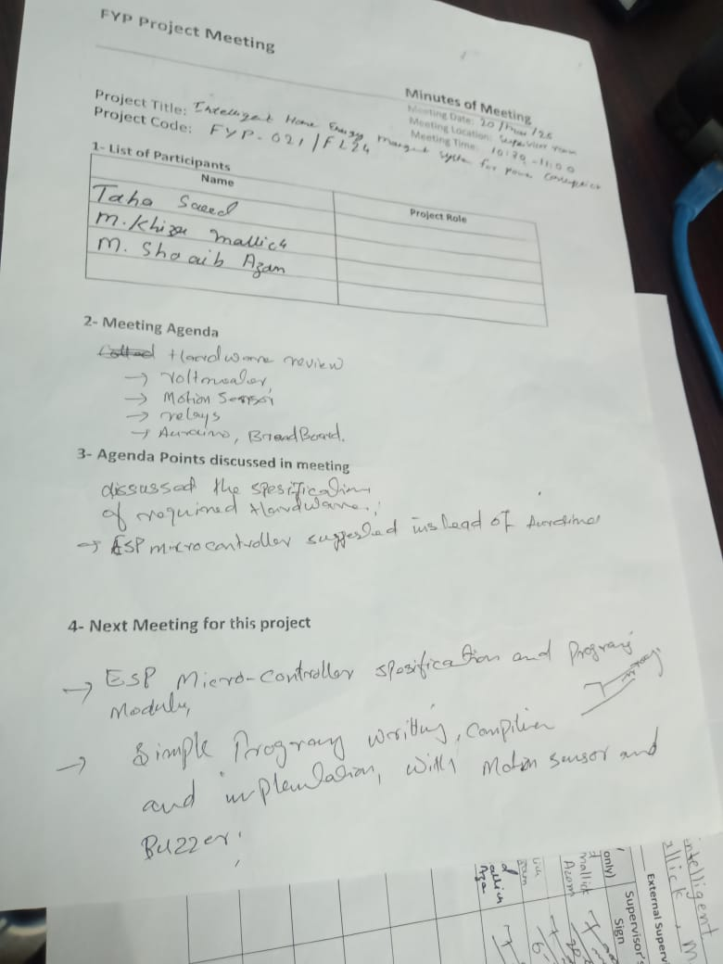





### A8. DOCUMENT CHANGE RECORD

|  |  |  |  |
| --- | --- | --- | --- |
| **Date** | **Version** | **Author** | **Change Details** |
| 09-06-2025 | 01 | M.Khizer Mallick | Created all chapters details |
| 11-06-2025 | 02 | Taha Saeed | Fixed typos, mistakes and formatting |
| 13-06-2025 | 03 | M.Shoaib Azam, M.Khizer | Added SRS, SDS |
|  |  |  |  |

### A9. PROJECT PROGRESS





**A10. RESEARCH PAPER**

### Design and implementation of a Smart Home Energy Management System With Integrated Green Energy Monitoring considering energy saving

* ALiero MS, Qureshi KN, Pasha MF, Jeon G (2021) Smart home energy management systems in Internet of things networks for green cities demands and services. Environ Technol Innov 20:101443
* Mahmoud H Elkholy, Tomonobu Senjyu, Mohammed Elsayed Lotfy, Abdelrahman Elgarhy, Nehad S Ali, Tamer S Gaafar
* Sustainability 14 (21), 13840, 2022

### A smart home energy management system using IoT and big data analytics approach

* Abdul-Rahman Al-Ali, Imran A Zualkernan, Mohammed Rashid, Ragini Gupta, Mazin AliKarar
* IEEE Transactions on Consumer Electronics 63 (4), 426-434, 2017

### Smart home energy management systems: Research challenges and survey

* Ali Raza, Li Jingzhao, Yazeed Ghadi, Muhammad Adnan, Mansoor Ali
* Alexandria Engineering Journal 92, 117-170, 2024

### Smart Energy Management System Using Machine Learning

* Ali Akram, Sagheer Abbas, Muhammad Khan, Atifa Athar, Taher Ghazal, Hussam Al Hamadi
* Computers, Materials & Continua 78 (1), 2024

### A smart home energy management approach incorporating an enhanced northern goshawk optimizer to enhance user comfort, minimize costs, and promote efficient energy consumption

* Heba Youssef, Salah Kamel, Mohamed H Hassan, Juan Yu, Murodbek Safaraliev
* International Journal of Hydrogen Energy 49, 644-658, 2024